DOM STUDENTA NR 2

STUDENT’S DORMITORY 2  
43-300 Bielsko-Biała  
ul. Spółdzielców 11

Investor:

Akademia Techniczno-Humanistyczna  
43-309 Bielsko-Biała  
ul. Willowa 2

**FIRE SAFETY**

**INSTRUCTION**

Bielsko-Biała, January 2016

FIRE SAFETY INSTRUCTION

Building: STUDENT’S DORMITORY 2

Document title:

43-300 Bielsko-Biała ul. Spółdzielców 11

Investor: Akademia Techniczno-Humanistyczna

43-309 Bielsko-Biała ul. Willowa 2

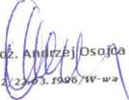Prepared by:

mgr inz. p

SGSP no Z04

P.U.H. „INSTAL-POŻ" s.c.

Kompleksowe zabezbieczenie p.poż.  
34-300 Żywiec, ul. Ks. Pr. St. Słonki 49  
tel.|fax 033-861 11 14  
tel. 0 502 645 233, 0 502 495 665  
Regon 072268985 NIP 553-21-12-363

Bielsko-Biała, 26 January 2016

Approved for use:

Signature of

BUILDING OWNER/  
ADMINISTRATOR

Instruction control chart

1. Chapter I.

The purpose and provisions of this document……………………………………………………..5

1. Chapter II.

Interpretation and definitions…………………………………………………………………………….. 6

1. Chapter III.

Fire protection conditions based on the building’s intended use, its actual use and its technical specifications…………………………………………………………………………………...8

1. Chapter IV.

The required fire safety equipment and fire extinguishers, inspections and maintenance ……………………………………………………………………………………………11

1. Chapter V.

Staff members’ tasks and obligations in the scope of fire safety and the principles for a safe use of the building………………………………………………………………………………24

1. Chapter VI.

Procedures for fire or other local hazard……………………………………………………………. 35

1. Chapter VII.

Evacuation Organisation and the practical means of controlling it…………………….. 43

1. Chapter VIII.

Instruction for works involving fire hazard…………………………………………………………. 48

1. Chapter IX.

Principles of briefing the Staff members on the fire protection regulations and the fire safety instruction………………………………………………………………………………………….55

1. Chapter X

Legal regulations…………………………………………………………………………………………………58

Schedules

Schedule 1 – Site plan

Schedule 2 – Emergency evacuation plan and the plan of distribution of the hand fire-fighting equipment and the fire-safety equipment

Schedule 3 – Distribution of the emergency lighting system components

Schedule 4 – Distribution of the elements of the gravity smoke vent system in the staircases

“Fire Safety Instruction”[1] control chart

|  |  |  |  |  |
| --- | --- | --- | --- | --- |
| No. | Revision  date | Revision performed in reference to: | Revision  conducted by: | Signature |
| 1. |  |  |  |  |
|  |  |  |  |
|  |  |
| 2. |  |  |  |  |
|  |  |  |  |
|  |  |
| 3. |  |  |  |  |
|  |  |  |  |
|  |  |
| 4. |  |  |  |  |
|  |  |  |  |
|  |  |
| 5. |  |  |  |  |
|  |  |  |  |
|  |  |

THE PURPOSE AND PROVISIONS OF THIS DOCUMENT

The fire safety instruction was prepared pursuant to the provisions of the Regulation of the Minister of Internal Affairs and Administration of

07 June 2010 on the fire protection of buildings, other building constructions and grounds, § 6.1. (Journal of Laws Dz.U. 2010, no 209, item 719).

The purpose of this document is to specify the basic fire protection principles for the building:

**STUDENT’S DORMITORY 2**

**43-300 Bielsko-Biała**

**ul. Spółdzielców 11**

The staff working in the building shall be briefed on the fire safety instruction within a month from its effective date, and the new employees on their first day of work; the briefing should be confirmed by a written statement, as set forth in chapter IX. The statement shall be kept in the employee’s personal file. The fire safety instruction has been prepared on the basis of the regulations and instructions regarding fire protection.

The Fire Safety Instruction shall be revised periodically, at least once in two years, and each time after any changes in the use of the building or in the technological process that affect the fire protection conditions.

The Fire Safety Instruction should always be available for the rescue teams.

Acronyms used in the text:

FAS - fire alarm system,

FRU - Fire and Rescue Unit

VFS - Voluntary Fire Service

SFS - State Fire Service

HHC - Human-related Hazard Category

Interpretation and definitions.

1. Fire safety means a condition in which the life or health hazard for humans has been eliminated, which is achieved by means of an effective legal standards system and the technical fire protection means as well as fire protection activities.
2. Fire hazard is a set of factors which affect the outbreak and propagation of fire and, in consequence, affect the safety of people, animals and property.
3. Fire load density is the heat energy which may arise when combustible materials burn in a room, a fire compartment or a flammable solids storage yard, expressed in MJ per a surface unit of the construction in question expressed in m2.
4. Emergency power-off button (EPO) is the button which stops the flow of current to all circuits with the exception of such system and equipment circuits which neet to remain operative during the fire.
5. Fire compartment is an area separated in such a way that the fire does not propagate into or outside of it in a given time.
6. Emergency evacuation conditions are all organisational and technical means undertaken to ensure prompt and safe evacuation from the hazard or fire zone.
7. Fire resistance of the structural components is a property measured with the length of time during which the element may perform its functions when on fire.
8. The buildings and parts of buildings which constitute separate fire compartments, defined as HH, belong to one or more of the human-related hazard categories mentioned below:

* HH I - includes rooms which may at the same time accommodate over 50 persons who are not permanent occupants of the rooms, and which are not fit for persons with limited movement capabilities,
* HH II - mainly for persons with limited movement capabilities, such as: hospitals, crèches, nurseries, care homes for elderly persons,
* HH III - public use, not falling under HH I or HH II,
* HH IV - residential,
* HH V - collective residential, not falling under HH I or HH II.

1. Whenever the Instruction mentions:

* Materials involving fire hazard , the following dangerous materials

are meant:

1. flammable gases,
2. flammable liquids with a flash-point below 328.15 K (55°C),
3. substances which, in contact with water, emit flammable gases,
4. substances which self-ignite on contact with air,
5. explosives and pyrotechnic substances,
6. substances which self-decompose or polymerize,
7. substances prone to self-ignition;

* storage yard fire compartment - means the part of the storage yard which is separated from the buildings and other constructions and storage yards in a manner legally specified for storage buildings, i.e. with an unoccupied strip of land of the legally prescribed width or with a fire wall exceeding the level of the stored goods by at least 0.5 m and with the fire resistance category of no less than REI 120;
* explosion hazard zone - means a space in which there may be an explosive mixture of flammable substances and the air or other

oxidising gases, with the concentration between the bottom and top explosive limits;

* engineered fire suppression systems - mean the devices, equipment and construction systems and solutions which are designed to prevent outbreak and propagation of fire;
* adjacent land - means a strip of land around the building with its width equal to the minimum allowed distance from other constructions due to the fire safety requirements set forth in the provisions of the Minister’s of Infrastructure regulation of 12 April 2002 on the technical requirements for buildings and their situation (Journal of Laws Dz.U,. no. 75, item 690, as amended.) hereinafter referred to as “technological-construction regulations”;
* fire safety equipment - means the equipment (fixed or semi-fixed, activated manually or automatically) which serves to detect and fight fire or limit its adverse effect and includes: fixed and semi-fixed fire extinguishing and protection devices, devices which are parts of the audible alarm system and the fire alarm system, including detection-notification devices, fire alarm receivers and fault warning receivers, emergency lighting systems, hydrants and hydrant valves, pumps in fire-fighting pumping stations, fire dampers, smoke vents, explosion protecting devices and fire doors and gates provided that they have a control system; emergency power off buttons and lifts for the rescue teams;
* protection of emergency routes from smoke - means protecting the emergency routes from such accumulation of smoke that could make safe evacuation impossible due to limited visibility or toxicity of the smoke;
* explosion hazard- means a possibility that flammable gases, the vapours of flammable liquids, dust or the fibres of flammable solids, in various conditions may create such mixtures with the air which explode, i.e. burn violently in the company of increased pressure, under the influence of an ignition initiating factor (spark, electric arc or exceeded flash-point);
* hydrant valve- is a manual cut-off valve fixed on the water supply system for fighting fire, fitted with a 52 head to enable the connection of fire hoses;
* fire-fighting pumping station- means the pumping station which supplies water to the water supply system for fighting fire.

CHAPTER III

FIRE PROTECTION CONDITIONS BASED ON THE BUILDING’S INTENDED USE, ITS ACTUAL USE AND ITS TECHNICAL SPECIFICATIONS.

1. Situation of the building

The Student’s Dormitory is a detached building situated in a low-density building area in Bielsko-Biała at ul. Spółdzielców 11.

1. Technical specifications of the building

* Number of storeys above ground
* 5
* 1
* 2,843 m2
* 10,500 m3
* 15.20 m
* Number of storeys under ground
* Surface
* Cubic capacity:
* Height

1. Fire classification of the building
   1. Human-related hazard, number of persons in the building

Due to its function, the building is classified as HHC V.

The maximum number of persons which may be present in the building: 166 students and 6 staff members.

* 1. Explosion hazard classification

The building has no rooms with areas classified as potentially explosive.

* 1. Height classification
* Number of storeys above ground: 5
* Height: 15.20 m (mid-rise MR)
* Number of storeys under ground: 1
  1. Fire load density

The Fire load density does not exceed 500 MJ/m2 in the store rooms and maintenance rooms.

1. Division into fire compartments

The building has been divided into 2 fire compartments.

* The basement with a surface of 474 m2 within which the following rooms have been separated with REI 60 walls and a ceiling: a gas boiler room, server room and a room with the hydrophore system for boosting pressure in the hydrant system. The entrances from the staircases to the cellars are closed with EI30 fire resistant doors.
* The ground floor and floors I, II, III, IV with the aggregate surface of 2370 m2 within which there are EI30 fire resistant doors at the entrances to the following rooms: office, utility room, reception office, 2 store rooms, server room). At the exits from the staircases, in the areas enclosed with smoke-proof doors, there are EI30 fire resistant doors.

1. Building construction, fire resistance rating

The building has been constructed in pre-fabricated timber-frame technology. A crosswise load bearing walls arrangement. The load bearing walls of the over ground storeys are made of pre-fabricated concrete slabs. The remaining walls are made of 25 cm thick cellular concrete blocks. The continuous footing and basement walls are reinforced concrete, monolith. The ceilings are made of pre-fabricated reinforced concrete slabs with circular section canals. Pre-fabricated reinforced concrete stairs.

The required fire resistance class of the building: “B”

1. Emergency evacuation conditions:

Vertical evacuation routes

There are 3 staircases in the building constructed with reinforced concrete and with a width of 1.16 m. All staircases in the building on all over ground storeys are separated from the evacuation corridors with Sa and Sm class smoke-proof doors. The doors are held in the open position by a system of electromagnetic locks controlled by smoke exhaust control units manufactured by D+H (when the detector detects smoke within the staircase, the control unit cuts off the power supply for the locks and the door closers close the doors.)

All staircases have been equipped with gravity smoke vents, which prevent the concentration of smoke in the vertical evacuation routes. The system is activated automatically once the fire detectors fixed within the staircases on each storey detect smoke; it is also possible to activate the system manually by the manual smoke vent buttons (fixed within each staircase on the ground floor and on the II and IV floors).

From the level of the basement storey evacuation is conducted by means of 3 staircases. The entrances from the staircases to the cellars are closed with EI30 fire resistant doors.

Horizontal evacuation routes

The horizontal evacuation routes are the axially oriented, 1.25 m wide, corridors. The smoke-proof doors which separate the staircases divide the corridors into horizontal sections with a maximum length of 50 m. The entrances to the residential rooms, leading directly from the staircases, in the areas enclosed with smoke-proof doors, have been fitted with EI30 class fire resistant doors. Additionally, the EI30 class fire resistant doors have been fixed on the ground level in the entrances to the following rooms: office, utility room, reception office, 2 storage rooms, server room.

Emergency exits

The building has 4 emergency exits on the ground level which lead directly to the outside, 3 staircase exits and the main exit next to the reception office (the exits are closed with 180/90 wide double doors opening to the outside). At the staircase emergency exits, which are normally closed and used only for emergency evacuation, there are boxes with keys to open the doors from the inside. The boxes have been marked with photoluminescent signs in accordance with the effective standards.

Along the evacuation routes there is an emergency lighting system with pictograms. The illumination provides amounts to:

* 1.0 Lx on the surface of the evacuation routes
* And 0.5 Lx in the open spaces.

The distribution of the emergency lighting lamps is presented in the form of plans (Schedule 3).

The emergency evacuation routes and exits have been marked with emergency signs in accordance with the effective standards.

The runs of the evacuation routes, the locations of the emergency exits and the evacuation directions are presented in the form of plans (Schedule 2).

The building has the following fire safety equipment:

* fire safety water pipe system with indoor hydrants 25 and a semi-rigid fire hose,
* emergency lighting system,
* automatic gravity smoke vents in the staircases,
* smoke-proof door automatic control system within the stair cases,
* emergency power off button,
* natural gas detection and shut-off system in the gas boiler room,
* outdoor hydrant network with DN80 hydrants (outside the building’s premises).

8. Technical systems in the building

The building has the following systems:

* indoor hot and cold water supply system,
* indoor sewage system,
* central heating system (gas boiler room)
* ventilation system,
* electric and lighting system,
* telecommunication infrastructure,
* lightning protection system,
* gas system,
* fire safety equipment systems (chapter IV).

9. Water supply for fire protection

Pursuant to the Regulation of the Minister of Internal Affairs and Administration of 24 July 2009 on water supply for fire protection and fire service access roads the required water supply for the purpose of extinguishing outdoor fire is 20 dm3/s.

The water is supplied by the local water supply system with outdoor hydrants DN80 located outside the Investor’s grounds (location Schedule 5).

1. Fire Service access road

The building is accessed by Spółdzielców street with a possibility to turn around on the parking adjacent to the building.

1. Distance from other constructions

The shortest distance from other constructions with cubic capacity is no less than 8 m.

**CHAPTER IV**

THE REQUIRED FIRE SAFETY EQUIPMENT AND FIRE EXTINGUISHERS, INSPECTIONS AND MAINTENANCE

1. The required fire safety equipment, inspections and maintenance

Fire safety equipment - means the equipment (fixed or semi-fixed, activated manually or automatically) which serves to detect and fight fire or limit its adverse effect and includes: fixed and semi-fixed fire extinguishing and protection devices, devices which are parts of the audible alarm system and the fire alarm system, including detection-notification devices, fire alarm receivers and fault warning receivers, emergency lighting systems, hydrants and hydrant valves, pumps in fire-fighting pumping stations, fire dampers, smoke vents, explosion protecting devices and fire doors and gates provided that they have a control system; emergency power off buttons and lifts for the rescue teams;

The fire safety equipment in the building should be consistent with the design approved by a fire safety expert in the scope of fire protection; the operation permit for the equipment is issued under the condition that the equipment has been adequately tested and its operability has been confirmed.

The fire safety equipment and the fire extinguishers should be inspected and maintained in accordance with the provisions of the Polish Standards for fire safety equipment and fire extinguishers which are to be found in the technical documentation and the user manuals for the respective equipment.

The above mentioned inspections and maintenance should be performed in accordance with the manufacturer's instructions and with the frequency of at least once a year.

The building has the following fire safety equipment:

* fire safety water pipe system with indoor hydrants 25 and a semi-rigid fire hose,
* emergency lighting system,
* automatic gravity smoke vents in the staircases,
* smoke-proof door automatic control system within the stair cases,
* emergency power off button,
* natural gas detection and shut-off system in the gas boiler room,
* outdoor hydrant network with DN80 hydrants (outside the building’s ground).

1. INDOOR HYDRANT SYSTEM
2. Indoor hydrant system characteristics

The building has a fire safety water pipe system with indoor hydrants 25 and a 30 rm semi-rigid fire hose. The system has 3 wet risers (each with 3 indoor hydrants on each over ground storey and 3 in the basement). The water is supplied through the hydrophore system for boosting pressure in the wet riser system (located in the maintenance room in the basement). The system is also equipped with:

* a priority valve,
* shut-off valves which shut off the damaged risers.

The hydrant system should meet the following hydraulic requirements:

* the minimum water supply efficiency measured at the outlet of the fire hose nozzle of 1.0 dm3/s,
* the pressure on the indoor hydrant shut-off valve should ensure the efficiency of 1.0 dm3/s with consideration of the fire hose nozzle used, and should not be lower than 0.2 MPa.
* The maximum working pressure in the fire safety water supply system on the shut-off valve should not exceed 1.2 MPa,
* it is possible to obtain water simultaneously from two hydrants provided that the pressure and efficiency requirements are met.

The horizontal coverage are of the indoor hydrants should cover the entire surface of the protected building, fire compartment or room with consideration of:

* the section length of the indoor hydrant hose specified in the standards,
* the efficient reach of the 3m fire stream in the fire compartments classified as human-related hazard (HH) found in buildings with more than one over ground storey, calculated for conical fog streams.

1. Inspections and maintenance

The indoor hydrants should be inspected and maintained in accordance with the provisions of the PN-EN 671-3 standard “Fixed Fire-Fighting Systems”. Indoor hydrant systems. Part 3: The indoor hydrant systems with semi-rigid fire hoses and flat fire hoses should be maintained in accordance with the operation and maintenance manual and the user’s manual provided by the manufacturer, and with a frequency of at least once a year.

The requirements are consistent with the Regulation of the Minister of Internal Affairs and Administration of 07 June 2010 on the fire protection of buildings, other building constructions and grounds.

Annual inspections and maintenance.

The inspections and maintenance should be performed by a competent person.

The hydrant hose should be unfolded to its full length, pressurised and the following should be verified:

1. If it is kept clear, not damaged and its elements have not corroded or are not leaking;
2. If the user manuals are clean and legible;
3. If its location is clearly marked;
4. If it is securely fixed to the wall as required;
5. If the water flow is steady and sufficient (it is advised to use a flow indicator and a pressure meter),
6. If the pressure meter (if used) works correctly and within its measuring range;
7. If there are no signs of damage, deformation, wear or cracks along the full length of the hose. If there are any signs of damage, the hose should be exchanged to a new one or pressure tested under the maximum working pressure;
8. If the hose clamps or binding is of the right type and duly clamped;
9. If the hose reel reels lightly in both directions;
10. For a tilted hose reel: if it reels easily and tilts by 180°,
11. For manual reels: if the shut-off valve is of the right type and if it works easily and correctly;
12. For automatic reels: if the automatic valve and the auxiliary service shut-off valve work correctly;
13. If the state of repair of the water supply pipes is adequate with special focus on the elastic parts (if they show any signs of wear or damage);
14. If the hydrant has a box - verify if it’s not damaged and its door opens easily;
15. If the fire hose nozzle works and if it is easy to use it;
16. If any significant repair is required, the hydrant should be marked as

“DAMAGED” (“USZKODZONY”) and the relevant person should notify the hydrant’s user/owner of this fact.

Periodical inspections and maintenance of all hoses.

Every 5 years all hoses should be subjected to a pressure test under the maximum working pressure in accordance with the EN 671-1 and/or EN 671-2 standards.

Inspections and maintenance documentation

After the inspection and all necessary measurements have been performed, the indoor hydrants should be marked by the authorised persons as “INSPECTED” (“SPRAWDZONE”). The appointed persons should keep records of all inspections, controls and tests on file. Such a record should specify

* the date (month and year) of the inspection and tests;
* the test results;
* the list of spare parts and when they were applied to the equipment;
* the list of any additional tests to be performed, if required;
* the date (month and year) of the next inspection and tests;
* the list of all indoor hydrants.

1. EMERGENCY LIGHTING SYSTEM
2. Emergency lighting system characteristics

The emergency lighting system consists of lamps with their own in-built system of NiCd batteries and a switch over system whose purpose is to switch the lamps over to the emergency power supply from the batteries if there is no voltage in the electrical system. Once the basic power supply is available again, the lamps go off automatically and the batteries re-charge.

The illumination should have the minimum capacity of:

* 1.0 Lx on the surface of the evacuation routes,
* and 0.5 Lx in the open spaces.

The emergency lighting lamps should have the autonomy of at least 1 hour. After 5 seconds the lamps should reach 50% of the required illumination capacity, and the full capacity should be reached no later than 60 seconds from the power cut.

The emergency lighting fittings’ purpose is to automatically shed light on the emergency evacuation routes if the power supply for the basic lighting system is cut and they are to enable safe evacuation of persons from the building. The fire safety systems should not be used for any other purposes than fire safety. The emergency lighting fittings are also used as lighting for the passageways during the power cuts with no fire emergency.

The Ontec S and Ontec AZ emergency lighting fittings fixed along the general passageways in the hotel section of the building serve also as an additional source of light during normal use; in such a situation the fittings work with the regular power supply of 230 V. This function may be activated with a switch located in the reception office and operated by the reception clerk.

There should be an “Emergency lighting inspection book” kept for the building. There should be an emergency lighting distribution plan attached to the book, specifying the lighting capacities of the system. The annual inspections conducted by the authorised bodies should be registered in the book. All devices used in the building must have the necessary and proper certificates and the declarations of conformity.

The lighting fittings perform a self-test.

SELF-TEST means the automatic and autonomic testing of the state of repair of the fittings or the back-up modules, therefore no additional devices or service technician's activity is required to perform the testing required by the PN-EN 50172 standard. The SELF TEST in the emergency lighting fittings makes it possible to keep the fittings in their full operational capacity by means of the regular functional control and the measurement of their autonomy. The SELF TEST function is controlled by a microprocessor device which controls many functions, such as:

- performance of the functional test TEST A,

- autonomy control TEST B,

- control of the power supply for recharging batteries,

- signalling fitting damage by switching-on a red LED diode,

The subsequent tests are activated by the internal clock on the dates determined by the microprocessor software. In accordance with the PN-EN 50172 standard, TEST A and TEST B must be performed every 30 days and every 360 days respectively. TEST A is a power supply cut simulation during which the lighting fitting is switched over to the emergency mode for the duration of 1 minute. During this time the individual fitting’s components are tested. In TEST B the lighting fitting is switched over to the emergency mode and its autonomy is measured until the time the batteries discharge. The measured autonomy is compared by the microprocessor with the autonomy required for the individual lighting fitting and if the former is lower the red diode signals battery damage. Thanks to the full discharge of the batteries (to the minimum voltage defined by the manufacturer) and the subsequent re-charge, the batteries are correctly formed. The emergency lighting fittings with the SELF-TEST function used for illuminating the emergency evacuation routes are made of typical lighting fittings used for the basic lighting system to which the back-up modules with the SELF-TEST function are added. As a result, it is possible to create a coherent emergency lighting system in which all lighting fittings are automatically tested.

The lighting fittings with the SELF-TEST function guarantee that the building administrator has full control over the state of repair of the entire emergency lighting system. The fittings meet one of the most important requirements of the PN-EN 60598-2-22 standard, which reads as follows: “Emergency lighting fittings with own power source should be equipped with a self-testing system or be connected to a remote testing system.” The only inconvenience in the case of the SELF-TESTING lighting fittings is the necessity of regular visual inspections of the LED diode which signals the defects, if any.

|  |  |
| --- | --- |
| Test type | Scope of activities |
| Daily test | Visual inspection of the lamp operation indicators to recognise the systems readiness to work. |
| Monthly test | Scope of activities:  a) switch on the emergency mode for each lighting fitting and each emergency exit sign illuminated by an internal light powered by a battery; in order to do the above simulate the basic power supply cut for the period of time necessary to make sure that every lamp works.  During this period of time it is necessary to verify that all lighting fittings and signs exist, are clean and function correctly.  At the end of each periodic test it is recommended that the basic power supply is restored and each indicator light or equipment is verified to make sure that they indicate the basic power supply restoration. |
| Annual test | Scope of activities:   1. Every lighting fitting and an internally illuminated sign need to be tested for a period of time equal to that required during the monthly tests, in the case of the full nominal duration, however - it needs to be consistent with the manufacturer's instruction. 2. The basic power supply needs to be restored and each indicator light or equipment needs to be verified to make sure that they indicate the basic power supply restoration. It is recommended to verify if the testing system operates correctly. 3. The test date and results need to be written down in the test book. |

* 1. EMERGENCY POWER OFF BUTTON (EPO)

Inspections and maintenance

The building has been equipped with an emergency power off button located inside the building next to the reception office.

List of documents which should be in possession of the building Owner/occupant

* Electrical system plan specifying the solutions regarding the manner in which the building power supply may be cut off with the help of the emergency power off button,
* EPO testing and operational test records,
* EPO inspections, tests and maintenance register.

Real-life EPO activation tests and EPO functionality testing should be conducted at least once a year.

The tests should be done by licensed and authorised persons. Every inspection needs to be followed by documentation (records) describing the condition of the emergency power off system. The relevant records need to be entered in the building log book.

The location of the emergency power off button needs to be marked with signs reading “Emergency power off button” (“Przeciwpożarowy wyłącznik prądu”) consistent with the PN-92/N-01256 standard.



off button,

* 1. AUTOMATIC DEVICE FOR THE EXHAUSTING OF SMOKE AND FUMES FROM THE STAIRCASES
     1. System characteristics

Gravity smoke venting systems serve to exhaust the volatile burning products (fumes) and the excess heat from the emergency evacuation routes during fire and their purpose is to enable safe evacuation of persons from the building. The fire safety systems should not be used for any other purposes than fire safety. It is allowed to use the gravity smoke venting system also for the purposes of regular ventilation. The ventilation function is a secondary function and does not work during a fire alarm.

Fumes from the staircases: KI, K2 and K3 are removed through vents located in the highest points of these staircases which are automatically opened by two actuators each. In order for the system to function correctly, the inflow of supplementary air is provided through the entrance doors in the basement location which are opened manually and blocked in the open position with a bottom kickstand. The systems are controlled by independent smoke exhaust control units fixed in the staircases on floor IV.

The system is automatically activated upon the detection of smoke by any detector fixed in the given staircase. Detector activation is signalled by the red diode on the detectors housing. In such a situation it is possible to close the automatically opened vents in the respective staircase after ventilation of the activated detector (the red diode goes off) and reset of the smoke exhaust control unit.

Manual activation of the smoke vent system is possible through the smoke vent buttons located in the respective staircase at the exit door on the ground level and on the walls of the respective staircases on the level of floors II and IV.

To activate the smoke vent system manually, it is necessary to break the glass protecting the button and to push the visible smoke vent button. The exhaust vents and the inlet vents open within 60 seconds after the button has been pushed.

To close the exhaust vents after manual activation of the system, it is necessary to open the housing of the manual smoke vent button and to press the side black button marked as alarm cancellation or to reset the smoke exhaust control unit.

The green light of the diode in the button’s housing means that the system is operational and on stand-by. The yellow light of the diode in the button’s housing means that there has been a system failure and immediate repair by the authorised maintenance team is required. The red light of the diode in the button’s housing means that there is a fire alarm and the exhaust and inlet vents have been opened. On the fourth floors on the RT 45 buttons there are ventilation buttons which enable the opening of the exhaust vent in the respective staircase to the required angle for ventilation. The same button enables to make a wider opening or to close the vent which was opened for ventilation. The ventilation function does not work during the fire alarm.

1. Inspections and maintenance[2]

The periodical inspections and maintenance of the vents need to be conducted in the scope and on the dates recommended by the manufacturer and specified in the operation and maintenance manual for the exhaust vents or in the user manuals prepared by the manufacturer and with the frequency of at least once a year. In accordance with the operation and maintenance manual, it is decided for the system fixed in the building that the inspections be conducted every 6 months.

Depending on the system, the basic maintenance activities include:

* visual inspection of the system devices,
* inspection of cable connections in reference to damage and dirt,
* inspection of smoke vent buttons,
* inspection of smoke detectors,
* manual emergency activation through the manual vent control unit,
* automatic emergency activation through a smoke sensor or the smoke vent button,
* inspection of the condition of batteries,
* visual inspection of the vents or windows after opening,
* inspection of the mountings and lubrication of ferrules, if necessary,
* making an entry in the “Building log book” to confirm completion of the inspection.

PROHIBITED ACTIVITIES

1. It is prohibited to block the exhaust and inflow vents in staircase KI with any items which may limit their clearance or obstruct their ability to open to full operational capacity.
2. It is prohibited to hang any materials diminishing or limiting the clearance of the exhaust vent in staircase K2 or to place any items which might obstruct the vent’s opening capacity on its surface or close to it.
3. There must be free access provided to all system components in order to perform maintenance or repairs.
4. There must be a constant access route to the manual smoke vent buttons with a width of at least 1 m and a height of at least 2 m counting from the floor surface.
5. SMOKE-PROOF DOOR AUTOMATIC CONTROL SYSTEM WITHIN THE STAIRCASES
6. System characteristics

Fire door control system’s purpose is to fire separate the safe emergency evacuation routes and temporarily limit the fire-covered area.

All staircases in the building on all over ground storeys are separated from the evacuation corridors with Sa and Sm class smoke-proof doors. The smoke-proof door in the individual staircase is normally kept open by the electromagnetic locks and will close automatically after the smoke vent button is pushed or the optical smoke detector is activated. Each door may be closed manually by pushing the release button located on the electromagnetic lock’s housing or on the wall next to it. This action results in the closing of the particular door for which the release button has been pushed. Re-instating the door to the open position is possible once the door wing has been manually opened and the magnet keeper situated on the wing is pressed to the electromagnetic lock’s armature plate. The manual closing of the fire door does not activate any alarm.

System components:

* RZN 4404-K V2 gravity smoke vents control units,
* BAZ 04-N-UT fire door control units manufactured by D+H whose purpose is to control the electromagnetic locks in the fire doors;
* STUMET electromagnetic keepers used to keep the fire doors open,
* LEP OSD23 optical smoke detectors which operate on the light scattering principle and recognize fire automatically.

1. Inspections

The periodical inspections and maintenance of the used fire door equipment should be conducted in the scope and terms recommended by the manufacturer and specified in the operation and maintenance manuals prepared by the manufacturer: inspections to be conducted every 6 months.

Please note

It is prohibited to block the fire doors and the ordinary doors equipped with door closers in the open position by placing any items which limit the movement of the door wings or disable the wing to close fully.

**1.6. FUEL GAS DETECTING SYSTEM**

1. System characteristics

There is a gas detecting-shut off system based on the AVE RG1-M METANO GAS DETECTOR module in the boiler room. The main purpose of the system is to protect buildings with gas fuelled boiler rooms, gas system sections in the buildings in which there is an accumulation of gas devices (e.g. gas fuelled cookers in mass catering facilities). If there is a risk of dangerous gas concentration the system may cut off the flow of gas in the system and at the same time enable the activation of other cooperating devices, such as the outdoor audible and visual alarm devices.

The basic components of the system are:

* gas detector,
* detecting and shut-off control unit of the AVE RG1-M METANO GAS DETECTOR type,
* MAG-3 dn 100 valve
* outdoor audible and visual alarm device.

The moment the gas concentration, e.g. methane has exceeded the I alarm level (for methane: 10% LEL, i.e. about 0.5% in the air volume: 5% causes explosion hazard) the ALI relay is switched on, the orange diode of the relevant detector is switched on and the outdoor alarm siren begins to flash. After the second alarm level has been exceeded, the AL2 relay is switched on, the indoor audible alarm is switched on, the red diode of the relevant detector is switched on, the outdoor audible alarm is switched on and after about 10 seconds the shut-off valve is automatically shut-off.

The gas flow shut-off will after a while result in decreased gas concentration and the alarms will be shut down; the shut-off valve will remain closed. The green memory diode of the detector which detected the exceeded second alarm level informs about the incident. The gas flow is re-instated manually but it must be kept in mind that there is a leakage in the system which needs to be localised and removed.

1. Inspections

The detection system should be periodically inspected in terms of the electrical and measurement properties under the conditions specified in the operation and maintenance manual prepared by the manufacturer and with the least frequency of once a year The inspection needs to be performed as well each time after alarm activation connected with gas detection, power cut longer than 1 hour, long-lasting operations in the alarm condition and after any renovation works which could affect the operation of the system.

1.7. OUTDOOR HYDRANTS

1. System characteristics

There are outdoor DN80 hydrants outside the investor’s grounds (Schedule 5)

1. Inspections

In accordance with the Regulation of the Minister of Internal Affairs and Administration of 24 July 2009 on on water supply for fire protection and fire service access roads, outdoor hydrants need to be inspected and maintained once a year.

The nominal efficiency of the fire protection outdoor DN80 hydrant, by the nominal pressure of 0.2 MPa measured on the hydrant valve during water intake, should amount to at least 10 dm 3/s.

The fire protection water supply system, for which the aggregate required quantity of water exceeds 20 dm 3/s should be designed and constructed in such a way that it is possible to take water from two neighbouring outdoor hydrants at the same time.

The maximum hydrostatic pressure in the fire protection water supply system must not exceed 1.6 MPa.

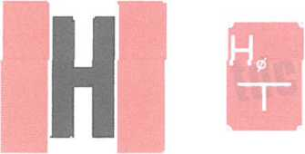The locations of the hydrants need to be marked as required by the Polish Standards including the hydrants characteristics on the supplementary sign.

Outdoor hydrants signs

The scope of inspection:

* Inspection of the outdoor hydrant’s state of repair,
* Verification whether the hydrant valve opens,
* Measurement of the nominal efficiency and the pressure on the outdoor hydrant valve with a flowmeter.

Inspection documentation

Each inspection of the outdoor hydrants must be followed by a record specifying the test results, the dates of the current and the following inspection and signed by the maintenance officer.

1. The required fire extinguishers, inspections and maintenance
2. The hand fire-fighting equipment’s purpose is to extinguish fires in their first phase, when they have just originated.
3. The hand fire-fighting equipment includes: fluid, dry-powder, carbon-dioxide and halon fire extinguishers, small fire-fighting devices (with up to 25 kg of the extinguishing medium).
4. Buildings should be equipped with portable fire extinguishers consistent with the Polish Standards which are the equivalents of the European Standards (EN) with regard to fire extinguishers, of with mobile fire extinguishers.
5. The type of fire extinguishers should be adequate for the types of fires which may occur in the building in accordance with the Polish Standards regarding the fire classification. One mass unit of the extinguishing medium of 2 kg (or 3 dm 3) contained in the fire extinguishers should cover (with the exception of cases set forth in the special provisions):

* each 100 m2 of a fire compartment surface in the building which is not protected with a fixed firefighting device:
* classified as: HHC I, HHC II, HHC III or HHC V, intended for production or storage purposes with the fire load density of over 500 MJ/m2,
* containing a room endangered with explosion;
* each 300 m2 of a fire compartment surface not mentioned in Section 1, with the exception of those classified as HHC IV.

1. The following principles need to be observed when deciding about the type of the firefighting equipment:

* for A-class fires (with incandescent burning of wood, paper, etc.) fluid, dry-powder ABC type fire extinguishers are used,
* for B-class fires (flammable liquids and melting solids, like: gasoline, alcohol, oil, grease, varnish, paraffin) fluid extinguishers, carbon-dioxide extinguishers, dry-powder extinguishers or halon extinguishers are used interchangeably,
* for C-class fires (burning gases such as: propane, acetylene, natural gas) dry-powder extinguishers, carbon-dioxide extinguishers or halon extinguishers are used interchangeably,
* for D-class fires (light metals, such as: magnesium, sodium, potassium, lithium) dry-powder extinguishers intended for this purpose are used,
* for any fires with the E-class indicator (potentially energized electrical devices and other materials close to the devices) carbon-dioxide extinguishers, halon or dry-powder extinguishers are used interchangeably.
* for F-class fires (grease and oil in kitchen devices) dry-powder extinguishers, carbon-dioxide extinguishers or fluid extinguishers are used interchangeably.

1. Fire extinguisher in the building should be located:

* in easily accessible and visible places, especially:
* at the entrance doors,
* on the staircases,
* on the corridors,
* at the exit doors from the rooms,
* at places which are not exposed to mechanical damage or heat (furnaces, heaters);
* in the case of multi-storey buildings: in the same places on each storey, if possible.

1. The following conditions should be met for proper distribution of fire extinguishers:

* the distance from any place in the building where any person may be present to the closest fire extinguisher must not exceed 30 m;
* there should be at least 1 m- wide access routes to the fire extinguishers.

1. The fire extinguishers should be inspected and maintained in accordance with the provisions of the Polish Standards for fire safety equipment and fire extinguishers which are to be found in the technical documentation and the user manuals for the respective equipment.
2. The inspections and maintenance mentioned in Section 8 should be performed in accordance with the manufacturer's instructions and with the frequency of at least once a year.
3. The locations of the fire extinguishers should be marked in accordance with the PN-92/N-01256-01 standard.
4. The above mentioned inspection needs to be followed by a fire extinguishers inspection record.
5. All dry-powder extinguishers with the tank water capacity of over 5 l shall undergo a tank pressure test conducted by the Office of Technical Inspection every 5 years.
6. All carbon-dioxide extinguishers undergo tank validation testing conducted by the Office of Technical Inspection every 10 years.
7. The dry-powder load in the dry-powder extinguishers should be exchanged every 5 years.
8. When the building is used, regular visual inspections should be conducted to verify if the fire extinguisher:
   * is in its intended location,
   * is kept clear and has a legible user instruction,
   * does not bear any signs of damage,
   * its indicators are not damaged,
   * the manometer pointer indicates the required pressure value,
   * the fire extinguisher is of the relevant type and volume.

Information regarding the inspection and maintenance conducted by authorised persons should be recorded on the inspection tag which should not cover any inscriptions made by the manufacturer and should be easy to recognize.

The following information should be recorded on the tag:

* activity type (inspection, maintenance, repair),
* name and address of the maintenance authority,
* a sign which indisputably identifies the person who performed the service,
* the date (year, month) of the next maintenance.

The minimum firefighting equipment requirements on the basis of the provisions of §32 Section 3 of the regulation of the Minister of Foreign Affairs and Administration of 07 June 2010 on the fire protection of buildings, other building constructions and grounds are as follows:

* for each 100 m2 of a fire compartment surface in the building which is not protected with a fixed firefighting device classified as: HHC I, HHC III there should be one mass unit of the extinguishing medium 2 kg (or 3 dm3) in the fire extinguishers,
* for each 300 m2 of a fire compartment surface in the building which is not protected with a fixed firefighting device classified as production or storage surface with the maximum fire load density of500 MJ/m2 there should be one mass unit of the extinguishing medium 2 kg (or 3 dm3) in the fire extinguishers.

|  |  |  |  |  |  |
| --- | --- | --- | --- | --- | --- |
| No. | Location | Surface  m2 | Fire class | Normative quantity of extinguishing medium kg | Number of fire extinguishers fixed |
| 1. | BASEMENT | 474 | Product.&Storage  Qd below 500 MJ/m2 | 4 | 5 ABC DP 4, i.e. 20 kg of extinguishing medium |
| 2. | GROUND FLOOR | 474 | HHC V | 10 | 4 ABC DP 4, i.e. 16 kg of extinguishing medium |
| 3. | FLOOR I | 474 | HHC V | 10 | 4 ABC DP 4, i.e. 16 kg of extinguishing medium |
| 4. | FLOOR II | 474 | HHC V | 10 | 4 ABC DP 4, i.e. 16 kg of extinguishing medium |
| 5. | FLOOR III | 474 | HHC V | 10 | 4 ABC DP 4, i.e. 16 kg of extinguishing medium |
| 6. | FLOOR IV | 474 | HHC V | 10 | 4 ABC DP 4, i.e. 16 kg of extinguishing medium |

ABC DP 4 is a 4 kg dry-powder extinguisher for fighting ABC class fires

The building has the legally required number of fire extinguishers

1. Fire doors

The fire doors constitute the boundaries of the fire compartments or fire-separated rooms. It is particularly important to consider the adjustment of the door closing hinges and door closers.

The hinges and the door closers should be adjusted immediately after an irregularity in their operations has been found, e.g. the doors do not close fully. The fire doors which do not close fully do not constitute any barrier for the heat and smoke.

The fire doors should be marked with a fire-door sign (“Drzwi pożarowe”) certified by the Scientific and Research Centre for Fire Protection in Józefów.

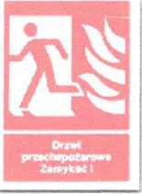

Maintenance

Each fire door, which is a component of the passive fire protection system, requires maintenance to keep their properties unchanged in the event of fire. The maintenance should be conducted periodically, with the consideration of the wear ratio (the wear ration depends on the number of times the doors are opened and the manner in which it is done; maintenance frequency: from 1 to 4 times a year).

Maintenance details:

1. Lock: the lock should be clean and lubricated; moreover, the proper penetration of the latch in the latch striker in the door frame (fig. A).
2. Handle: it is necessary to verify if the handle and the lock work properly;
3. Hinge: the hinge needs to be adjusted, the spring tightened and the accessories lubricated

(fig. B).

1. Intumescent seal: may be exchanged if clearly damaged or loose.
2. Expansion gaps: care should be taken to preserve the required expansion gaps between the door wing and the frame (fig. C).

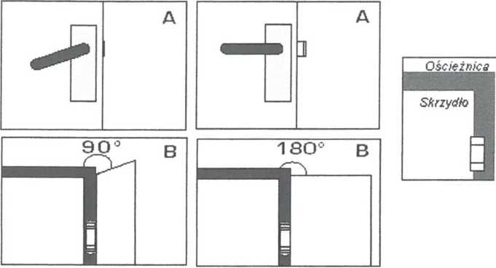

**CHAPTER V**

STAFF MEMBERS’ TASKS AND OBLIGATIONS IN THE SCOPE OF FIRE SAFETY AND THE PRINCIPLES FOR A SAFE USE OF THE BUILDING

1. Fire hazard.

Fire hazard is a set of factors which affect the outbreak and propagation of fire and, in consequence, affect the safety of people and property.

The potential causes of fire in the building

The fire in the rooms of the building may be caused by the following:

* glowing cigarette butts cast on combustible materials,
* short circuits, overloads in the electric system,
* leaving electrical devices unattended or putting heating devices directly on combustible materials,
* careless handling of open fire, including:
* leaving stoves and other similar devices with open fire unattended,
* leaving non-electrical sources of light unattended, e.g. candles,
* burning litter close to or in the buildings or other constructions,
* burning out vegetation remains,
* conducting renovation works in rooms with the use of torches in the presence of unsecured combustible material,
* heating up tar, asphalt binder and asphalt on combustible construction elements of buildings,
* incorrect use or maintenance of technical, heating, electric and gas devices and systems,
* improper storage of or use of combustible materials,
* lightning discharge,
* non-observance of the basic fire safety rules and regulations,
* causing fire or fire hazard intendedly or accidentally.

The factors which affect the fire safety of buildings result most frequently from their construction:

* combustibility of the construction components, such as the walls, ceilings, roof and interior decorations,
* combustibility of floors and floor coverings and wall coverings and decorations, ceilings and suspended ceilings, especially on the general passageways which may serve as emergency evacuation routes,
* keeping, collecting (storage) of excessive combustible materials, including highly flammable, fragmented and chemically dangerous ones in one fire-separation location, close to where people reside and to the evacuation routes,
* dense situation of neighbouring buildings, especially those with combustible construction, and placing fire-dangerous materials at combustible walls,
* equipping the building interiors only or mainly with highly flammable or combustible items, such as furniture, decoration devices and items, as a result of which, in the event of fire, the entire space inflames almost immediately and the fire, together with the equally dangerous fumes and smoke, propagates in various directions through the open or flammable doors or other spaces,
* the storage, even if only temporary, of combustible materials on the internal passageways which may be used for evacuation or close to passage and exit doors, and also fitting the cavities along, over or under the evacuation routes, the lacings and vestibules, etc. with such materials,

FIRE SAFETY INSTRUCTION 24

* allowing for draughts or vertical air currents to originate (ventilation pipe or cable transition ways, etc.) which even in the case of small fire may result in the flame propagation to a significant distance,
* disorder and lack of cleanliness in the rooms and on the internal passageways, and the lack of systematic emptying of the waste buckets and garbage bins.

1. Fire safety tasks and obligations

In accordance with the Act on fire safety of 24 August 1991:

1. A natural or legal person, an organisation or institution which use a location, building, construction or ground is obliged to protect it from the risk of fire or other local risks.
2. The owner, administrator or occupant of a building, construction or ground, including the entities mentioned in Section 1, shall be liable for any infringement of the fire safety regulations, in the manner and under the terms and conditions set forth in other regulations.

In accordance with *the Regulation of the Minister of Internal Affairs and Administration of 07 June*

*2010 on the fire protection of buildings, other building constructions and grounds* the owners, administrators or occupants of buildings and storage sites and umbrella roofs, with the exception of residential buildings and single-family houses shall:

1. keep the fire safety equipment and fire extinguishers fully operational and functional,
2. equip the constructions with emergency power off buttons in accordance with the engineering and construction regulations,
3. put fire instructions including the emergency phone numbers in visible places,
4. mark the following with signs consistent with the Polish Standards:

* emergency evacuation routes and exits and rooms in which at least 2 emergency exits are required as set forth in the engineering and construction regulations in such a manner that all information required for evacuation is provided,
* fire safety equipment and fire extinguisher locations,
* locations of the fire safety equipment control units,
* assembly points, locations of keys to the emergency exits,
* fire doors,
* fire service access roads.

1. The owners or administrators of the grounds shall keep the fire service access roads running across the grounds in such a condition that the roads may be used by fire service vehicles in accordance with the regulations regarding water supply for fire protection and fire service access roads.
2. The owner or administrator of a building shall apply such solutions that the fire safety requirements for the construction are met in a manner set forth in the engineering and construction regulations.

**Obligations related to the provision of emergency evacuation conditions**

In accordance with *the Regulation of the Minister of Internal Affairs and Administration of* 07*June 2010 on the fire protection of buildings, other building constructions and grounds*:

There should be appropriate evacuation conditions provided from all locations in the building in which people may be present, which enable fast and safe evacuation from the danger or fire zone and are adapted to the number and fitness of the persons present in the building and to the building’s construction and dimensions; moreover, the engineered fire suppression systems should be used, which include:

* providing the sufficient number, width and height of emergency exits;
* observing the allowed length, height and width of the emergency passages and access routes;
* providing the fire safe enclosure and fire barriers for the evacuation routes and rooms;
* protecting the evacuation routes mentioned in the construction regulations from smoke concentration, including:
  + the use of devices
  + preventing smoke concentration or devices and other engineering and construction solutions which ensure smoke exhaust;
* providing emergency lighting (evacuation and back-up lighting) in the rooms and on the evacuation routes mentioned in the engineering and construction regulations;
* providing a possibility to transmit warning signals and verbal warnings through the audible warning system in the buildings for which it is required.

The required evacuation conditions are set forth in the engineering and construction provisions of the Regulation of the Minister of Infrastructure of 12 April 2002 on the technical specifications of buildings and their situation (Journal of Laws Dz.U., 2010, no 75, item 690).

The existing used building is deemed as posing life hazard for people when its technical conditions do not provide any possibility of evacuation.

The technical conditions mentioned above are determined on the basis of the following findings:

* the width of the emergency passage, access route or emergency exit or the steps or landing in an emergency staircase is narrower by 1/3 than the width provided for in the engineering and construction regulations;
* the length of the emergency passage or access route is longer by over 100 % than the length provided for in the engineering and construction regulations;
* there is a fire compartment in the room or on the evacuation route which has been classified as: HCC I, HCC II or HCC V:
* ceiling or suspended ceiling covering is made of highly flammable material or

of material which melts and drops under the influence of fire, or floor covering is made of highly flammable material,

* wall covering on the emergency evacuation route is made of highly flammable material if two evacuation directions have not been provided;
* no emergency staircase has been separated in a high-rise building other than a residential building or in a skyscraper, as set forth in the engineering and construction regulations;
* the emergency evacuation routes mentioned in the engineering and construction regulations have not been secured from smoke concentration in a manner specified in the regulations;
* there is no required emergency lighting in the fire compartment classified as HHC I, HHC II or HHC V or on the emergency evacuation route running from the compartment to the outside of the building.

The owner or administrator of a building shall apply such solutions that the fire safety requirements for the construction are met in a manner set forth in the engineering and construction regulations.

1. Building owner’s tasks and obligations

The building owner, who ensures fire safety of the building, is especially obliged to do the following:

* to manage the fire safety issues,
* to meet the fire safety construction, installation and technological requirements,
* to equip the building and the ground with fire security and rescue equipment, and with firefighting equipment in accordance with the principles set forth in the relevant regulations,
* to provide maintenance and repair services for the fire safety equipment and devices in accordance with the rules and requirements which guarantee that they remain operational and functional,
* to ensure safety of and a possibility to evacuate to the persons present in the building, construction or on the ground,
* to prepare the building and the ground for conducting a rescue action,
* to brief the subordinate staff on the fire-safety regulations,
* to determine procedures for fire, natural disasters or other local hazards including the procedures for announcing and conducting evacuation.

The Building Owner’s basic tasks in reference to fire safety include:

* to ensure that staff are trained on the fire procedures, including the procedures for announcing and conducting evacuation; the training shall be conducted by a person with the adequate qualifications 3,
* to manage the rescue and firefighting activities until the command is taken over by the first-arrived fire service commander,
* to cooperate with and to give all necessary information to the fire fighter managing the rescue actions,
* to initiate fire preventive actions on the construction premises,
* to supervise the staff to ensure that the fire safety requirements and rules for the construction premises are observed,
* to ensure timely inspections, tests, and maintenance of the engineer-, fire-safety-, and fire-fighting systems and devices,
* to supervise the correct organisation and security of works involving fire hazard (welding, etc.) conducted inside the construction,
* to brief the employees of the contractors performing activities on the construction premises on the fire safety requirements for the construction and to make sure that the requirements are observed,
* to take disciplinary measures against the staff and occupants who do not observe the fire safety rules,
* to undertake activities to remove the irregularities which may cause an a fire- or explosion hazard,
* to perform the orders of the control authorities with regard to providing the adequate fire safety conditions.

3 Qualifications set forth in the Regulation of the Minister of Internal Affairs and Administration of 08 December 1998 on the requirements regarding the professional qualifications and the requirements regarding the psychological and physical condition of persons working in fire service units, and regarding the professional qualifications of other persons who perform fire safety activities. (Journal of Laws Dz. U. 2010, no 159, item 1050).

**2.2. Obligations of the staff working in the building**

Every member of the building’s staff is obliged to:

* participate in the fire-safety trainings organised by their managers,
* pay attention to any behaviour of the student's which may cause fire,
* know the fire emergency (or other hazard) procedures and the rules of notifying the Fire Service, including the procedures for communicating and conducting evacuation,
* know when and how to use the fire safety devices in the building,
* know the rules for the use of the hand fire-fighting equipment,
* immediately undertake activities to remove the irregularities which may cause an a fire- or explosion hazard,
* inform their managers about their observations and conclusions regarding the improvement of fire safety,
* know the fire safety requirements for the building’s premises and its individual parts and to follow them with no exceptions.

In the case of fire every staff member is obliged to:

* alarm the persons in the hazard zone and in its neighbourhood,
* notify the Building Manager about the event and about the necessity to call the Fire Service,
* evacuate the persons from the building,
* begin the rescue and firefighting action,
* follow the orders of the person managing the rescue operation.

All staff members are obliged to know the current information regarding:

* the location of the alarm devices and the alarm rules,
* the location of the hand fire-fighting equipment and the fire safety devices,
* the plan of the building, the passageways and the directions of emergency routes and exits,
* providing first aid to those injured from fire and smoke,
* the location of the keys to the rooms including the spare keys,
* the location of the emergency power off button and the gas valve,
* the location of the emergency assembly points,

The persons who lock rooms after the end of the work are obliged to:

* make sure that no fire has originated,
* switch off all electrical devices which are not devised for constant use.

**THE RECEPTION OFFICERS MAKE SURE THAT NO VEHICLES PARK ON THE   
NO-PARKING SPACES ON THE PARKING LOT ADJACENT TO THE BUILDING TO ENSURE THE REQUIRED FIRE SERVICE ACCESS ROAD**

1. Prohibited activities

In order to ensure the appropriate safety conditions in the building and the adjacent grounds, it is prohibited to conduct activities which may cause outbreak or propagation of fire, or activities which make hinder the rescue or evacuation operations, including:

* the storage of combustible materials on the general passageways which may be used for evacuation or placing items on these passageways in such a manner that their
* width or height is reduced to below the required values set forth in the engineering and construction regulations;
* closing the emergency exit doors in a manner which makes it impossible to use them immediately in the event of fire or other emergency;
* the use of open fire, smoking and doing anything which might initiate the inflammation of materials ( the smoking ban and the ban on open fire are valid for the entire building with the exception of places designated for this purpose and marked as required),
* the use of systems, devices or tools which are not operative or which have not been inspected at the dates and with the frequency set forth in the construction law, or using them in a manner which is not consistent with their intended use or with the conditions specified by the manufacturer, if it may cause outbreak of fire, explosion or flame propagation;
* preheating tar or other materials with open fire at a distance shorter than 5 m from the building, a warehouse or a storage site with flammable materials which are adjacent to the building; however, these activities are allowed on roofs with non-combustible construction and covering in structures under construction and in other structures if adequate preheaters, intended for this purpose, are used;
* lighting fire, burning out of the surface layer of soil and grass in a place where combustible materials or the neighbouring constructions may inflame;
* store combustible materials, including vegetation remains outside the buildings, closer than 4 m from the boundary of the adjacent plot of land;
* use electrical heating devices placed directly on combustible materials, with the exception of devices which are used in accordance with the conditions specified by the manufacturer;
* store combustible materials and to place combustible decoration or fixtures and fittings closer than 0.5 m from:
* the devices and equipment whose external surfaces may heat up to over 373.15 K (100 C),
* electricity power line with the voltage of over 1 kV, earth conductors, the static wires of grounding systems and operating electric switchboards, electric power conductors and sockets with the voltage of over 400 V;
* the use of combustible materials as lamp sheds, with the exception of flame resistant or limited flammability materials if they are placed at least 0.05 m from the light bulb;
* fixing of lighting fittings and electric system gear, such as: switches and sockets, directly on combustible surface, if their construction is such that it does not prevent the surface from inflaming;
* the storage of combustible materials in the maintenance rooms, on the non-habitable lofts and attics and on the general passageways and in the cellars;
* placing room decoration elements, devices and equipment in such a manner that they decrease the size of the emergency passageway below the limits indicated in the technical-construction regulations;
* the obstruction or limitation of access to:
* fire extinguishers and fire safety equipment,
* fire safety water supplies,
  + - the equipment activating and controlling extinguisher systems and other systems which have influence on the fire safety in the building,
    - the emergency exits or windows for the rescue teams,
    - the emergency power off buttons and dashboards and the main gas valves.
  1. While using the electrical system and devices, it is prohibited to:
* repair the damaged fuses (if applicable),
* construct temporary electric systems and to use damaged sockets, plugs, extension cords, etc.,
* have too many electric devices switched on at the same time, whicy may lead to the electric system’s overload,
* leave the following unattended: electrical heaters when switched on (with the exception of those which have the manufacturer's approval for unattended operations), water heaters or soldering tools and other devices which are not intended for constant operation; use the tools which are private property of a staff member,
* put heating devices on combustible materials and items, work closer than 50 cm from combustible materials,
* use combustible materials as lamp sheds, with the exception of flame resistant materials if they are placed at least 0.05 m from the light bulb,
* leave the machines and devices connected to the electrical system (except the rooms heated by storage heaters and other heating devices approved by the manufacturer to operate unattended),
* obstruct the access to electric dashboards, breaker switches, switches and the similar electrical devices with various items,
* place TV sets, computer monitors and other strong sources of light, etc., closer than 50 cm from highly flammable materials (curtains, drapes),
* use fixtures and devices whose technical condition may cause an outbreak of fire, an explosion or flame propagation.
  1. While working with materials involving fire hazard it is required to:
* perform all activities related to the manufacturing, processing, machining, transport or storage of dangerous materials in accordance with the fire safety conditions set forth in the fire safety instruction or in accordance with the conditions specified by the manufacturer;
* store the materials involving fire hazard on the work station in the quantity no bigger than that required for a 24-hour demand or production, if not provided otherwise by the specific regulations;
* to store the excessive materials involving fire hazard in a separate store room dedicated for this purpose;
* to store the materials involving fire hazard in such a manner that outbreak of fire or explosion as a result of storage or mutual interactions are not possible;
* To store liquids with a flash point of below 328.15 K (55 °C) only in containers, devices and systems adapted for this purpose, made of materials which are at least flame retardant, which carry away static electric charges, are designed to retain spills and are secured from breaking.

1. Rules for the use of the technical systems in the building

The analysis of the potential factors and causes for fires in buildings shows that the various technical systems and devices which may have a significant influence on the containment or mitigation of the risk of an outbreak or propagation of fire, and the effectiveness of the rescue operations, are a serious source of fire hazard.

The effective fire safety regulations specify the following general fire protection principles for the systems:

* the technical systems and devices in the building need to meet the technical specifications set forth in the Polish Standards (which are equivalent to the European Standards) and the specific regulations as regards fire safety,
* the functions and purpose of the building and the hazard factors resulting therefrom need to be taken into account while selecting the systems and devices,
* all technical systems and devices need to be used and kept in a condition consistent with the manufacturer’s technical specifications and requirements, including the periodical inspections and maintenance,
* it is prohibited to use systems and devices whose technical condition may cause an outbreak of fire, an explosion or flame propagation.

The state of repair of the systems and devices mentioned in this chapter may be inspected only by persons with the relevant professional qualifications (professional license).

The given dates and scope of the periodical system inspections are based on Section 62 of the Act of 07 July 1994 Construction Law (Journal of Laws Dz.U. 2006, no 159, item 1118, as amended).

The other legal regulations and standards and the manufacturer's instructions are listed in the footnotes.

To ensure the correct and safe use of the technical systems and devices in the building, the requirements mentioned below need to be met.

1. Electric system and devices.

The frequency of the electric measurements transpires from the requirements of the Construction Law Act (Act of 07. 07. 1994, Journal of Laws of Dz.U. 1994, no. 89, item 414 as amended.), the Energy Law Act (Act of 10. 04. 1997 r., Journal of Laws Dz. U. of 1997, no. 54 item 348 and no. 158 item 1042, as amended) and the shock protection regulations (PN- HD 60364 on low voltage systems) and fire safety regulations (the Regulation of the Minister of Internal Affairs of 21. 04. 2006 ., Journal of Laws Dz.U. 2006 no 80 item 563).

The electric system needs to be periodically inspected and tested with the frequency of at least once per 5 years in terms of:

* the effectiveness of the used shock-protection means,
* the working conductor’s insulation resistance,
* the allowed voltage and load limits,
* the illumination strength of the emergency lights and their autonomy.

The frequency of the periodical system inspections should be decided with consideration of the type of system and equipment, its use and operations, the frequency and quality of maintenance and the external factors to which it is exposed.

The justified requirements regarding the dates of the performance measurements of the electric devices and systems are set forth in the “Periodical testing instructions” (“Wytyczne wykonywania badań okresowych”) prepared by COBR “Elektromontaż” in 1999.

PERFORMANCE MEASUREMENT FREQUENCIES FOR ELECTRIC DEVICES AND

SYSTEMS

|  |  |  |  |
| --- | --- | --- | --- |
| No. | Room type | Measurement Frequencies for | |
| Insulation resistance | Effectiveness of shock protection |
| 1 | With caustic fumes | At least every year | At least every year |
| 2 | With explosion hazard | At least every year | At least every year |
| 3 | Open space | At least every 5 years | At least every year |
| 4 | Very humid with humidity of ca. 100% and temporarily humid (75 to 100%) | At least every 5 years | At least every year |
| 5 | Hot (with air temperature exceeding 35 C) | At least every 5 years | At least every year |
| 6 | With fire hazard. | At least every year | At least every 5 years |
| 7 | With human-related risk (HHC I, HHC II, HHC III, HHC V) | At least every year | At least every 5 years |
| 8 | With high dust concentration | At least every 5 years | At least every 5 years |
| 9 | Other than mentioned in 1-8 | At least every 5 years | At least every 5 years |

The periodical tests for the individual systems should be conducted by licensed and authorised persons. Every test needs to be followed by documentation (records) describing the condition of the tested system. The relevant records need to be entered in the building log book.

1. Lightning protection system.

The periodical testing of the lightning protection system includes the activities necessary to assess the technical condition, performance parameters, control quality and energetic efficiency of the system and its devices and the persons operating and maintaining it should have the required qualifications confirmed with a license issued by the relevant technical inspection body.

The periodical tests’ and measurements’ purpose is to verify whether the technical condition of the system has not deteriorated during its use to a degree in which its further safe use could be at risk.

The periodical testing includes:

1. An inspection of the lighting protection device: inspection of the conductors, connecting components, brackets, mounting.
2. A verification of the electric continuity of the lightning protection device.
3. A lightning grounding electrode’s resistance measurement.
4. An inspection of the devices limiting overvoltage in the electric system and in the signal transmission systems.

In the case of any changes in the building, equipment or systems, the effectiveness of the lightning protection device's performance needs to be verified, including:

1. The condition of all connections and mountings in the lightning protection device.
2. Corrosion degree, especially on the level of the ground.
3. The required safe distance between the elements of the lightning protection system and the protected devices or construction elements of the building.
4. The condition of the eqiupotential bondings inside the building.
5. The condition of the devices limiting overvoltage and the fuses protecting them.
6. In the case of any changes, it needs to be verified whether the new parts of the indoor and outdoor system have been correctly made.

The lightning protection system should be maintained and inspected by a lightning protection expert.

The periodical testing of the lightning protection devices should be conducted at least every 5 years and each time after any changes to or repairs of the lightning protection device, or if it has been found that the building has been struck by lightning.

The fire protection device’s card needs to be filed together with the engineering and construction documentation of the building (building log book) and all defects found during the inspection must be immediately removed.

1. Ventilation system.

The periodical inspection and cleaning needs to be conducted as specified below:

The gravity and mechanical ventilation system ducts need to be cleaned from pollution at least once a year.

The gravity ventilation system’s ducts’ technical condition needs to be inspected at least once a year.

The inspections of the technical condition of the gravity ventilation system's ducts should be conducted by a chimney sweep master.

1. Flues

Pollution from the smoke and exhaust ducts of gas-fired furnace need to be removed (cleaned)

at least 2 times a year.

Moreover, in accordance with Section 62 of the Construction Law Act, the flues (smoke,

exhaust and ventilation ducts) must have their technical condition inspected at least

once a year.

The inspection of the flue's technical condition should be conducted:

1. by persons with master qualifications in the chimney sweeping craft, as regards the smoke ducts and the gravity exhaust and ventilation ducts,
2. by persons with the relevant licence in construction as regards the flues mentioned in Section 1 and industrial chimneys, detached chimneys and the chimneys or flues in which the chimney draught is forced mechanically.

The inspection should include in particular:

* a verification whether the flues are unobstructed and what the chimney draught’s strength is (negative pressure) with closed windows.
* a verification of the possibility to clean and inspect the flues and auxiliary devices,
* an inspection of the general technical condition of the flues (usability, damages) along their entire length, including the ducts, vent connectors, pipes and connectors, manholes, ladders, cleaning and inspection doors, chimney sweep’s benches and chimney pots,
* making sure that the inlet and outlet ventilation devices fixed in the rooms with heating devices (kitchen stoves, water flow heaters, central heating boilers, etc.) are operational,
* making sure that there are no other irregularities which could be potentially dangerous, e.g. flammable materials at the chimney, incorrect connections, missing or damaged auxiliary devices,
* inspection of the protection of exhaust ducts from acid corrosion, inspection of chimney whitewashing in the attic.

1. Piped natural gas supply system.

The system should be inspected for any potential leakage in the pipelines and fittings at least once a year.

CHAPTER VI

PROCEDURES FOR FIRE OR OTHER LOCAL HAZARD

1. Communicating an alarm
   1. Every staff member or tenant in the building who has noticed fire or has information of fire is obliged to keep calm, not to cause panic, and immediately alert the persons who are in the area of the actual or potential hazard and all others nearby.

1.2. Immediately inform the reception officer about the incident

1.3. The reception officer calls the State Fire Service. The State Fire Service should be called from the closest phone available.

**TELEPHONE NUMBERS**

**998 OR 112**

After a telephone connection with the State Fire Service has been made, the following must be stated clearly:

* the address of the place at which the fire has originated,
* the incident type: fire, explosion, other,
* what is on fire or other characteristics of the incident,
* if human life is at risk,
* the number of the telephone from which the call is made and the caller's name.

Please note!

Do not hang up before you have heard that the notification has been accepted. If it is found during the activities conducted before the arrival of the Fire Service that the alarm was false, it is necessary to immediately inform the Fire Service in Bielsko Biała under the following phone number: 998 or 112.

1. If necessary (accident, failure, etc.), please call:

**the Ambulance Service or the Police**

* **no. 999**
* **no. 997**
* **no. 991**
* **no. 992**

**Electricity Emergency Service Gas Emergency Service**

1

C:\Users\MARIUS~1\AppData\Local\Temp\FineReader12.00\media\image14.jpeg

1. Notify the Manager of the Building and other fire wardens.

Fire emergency call tree.

|  |  |  |  |
| --- | --- | --- | --- |
| No. | Name and Surname | Function | Telephone no. |
| 1. |  |  |  |
| 2. |  |  |  |
| 3. |  |  |  |

1. To communicate a fire alarm for the building, the voice alarm system should be used.

**THE SIGNAL TO RAISE FIRE ALARM AND BEGIN EMERGENCY EVACUATION   
IS A WARNING MADE WITH THE USE OF THE VOICE ALARM SYSTEM  
BY THE STAFF MEMBER WHO HAS NOTICED THE FIRE**

**ATTENTION!! - FIRE!! - EVACUATION!!**

**THE ALARM NEEDS TO BE COMMUNICATED VERBALLY ON EACH STOREY AND IN EACH PART  
OF THE BUILDING IN WHICH THERE IS A RISK OF FIRE**



1. Fire-fighting and rescue operation
   1. It is necessary to begin to evacuate the endangered persons and to start the fire-fighting and rescue operation with the hand firefighting equipment at the same time the State Fire Fighting Service is being notified.
   2. Until the time the Manager or the fire squads of the State Fire Fighting Service arrive, the operation is lead by the below mentioned fire wardens in the following order:
2. Student’s Dormitory ADMINISTATOR
3. Person in charge of the staff members during the absence of the Student’s Dormitory Manager

Reception officer: in the afternoon and at night.

* 1. The person in charge of the operation precisely determines the location of the fire, its propagation routes, the risk for the tenants, the accessibility of the emergency evacuation routes. Afterwards, he/she makes a decision regarding the scope of evacuation.
  2. All other persons present on the building’s premises are obliged to follow the leader’s instructions with no exceptions and to perform their orders.
  3. Once the fire squads of the State Fire Service have arrived, the person in charge of the rescue operation is obliged to inform their commander about the course of the operation so far and about the given orders and to hand over the command to the fire squad commander and to follow his/her orders.
  4. The arrival of the fire squads does not release the persons involved in the rescue operation from the obligation to continue the fire fighting and evacuation activities in reference to persons and property.
  5. Every staff member who begins the fire-fighting and rescue operation should bear the following principles in mind:
* first - rescue the persons at risk,
* shut off the electric current supply to the rooms on fire or to those in which there is an immediate risk of fire with the use of the main power circuit breaker,
* shut off the gas supply to the rooms on fire or to those in which there is an immediate risk of fire with the use of the main gas valve,
* remove combustible materials, especially those which may cause explosion or enhance the flame propagation, from the reach of the fire, if possible,
* when entering the rooms and spaces with high smoke concentration stay as close to the floor as possible and secure your airways with the use of simple means, such as: a humid tissue, tampon or gauze, etc.,
* please keep in mind that rescue activities have priority before firefighting activities,
* fast and correct activation of the hand firefighting equipment will make it possible to extinguish the fire while it's still small.

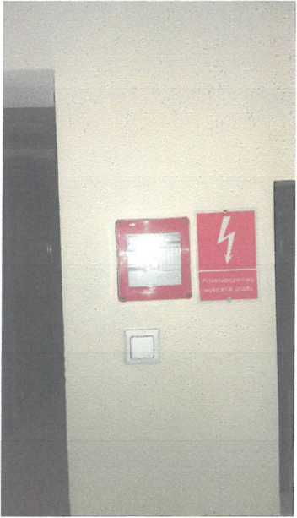

The emergency power off button is located on the wall of the reception office in the main hall

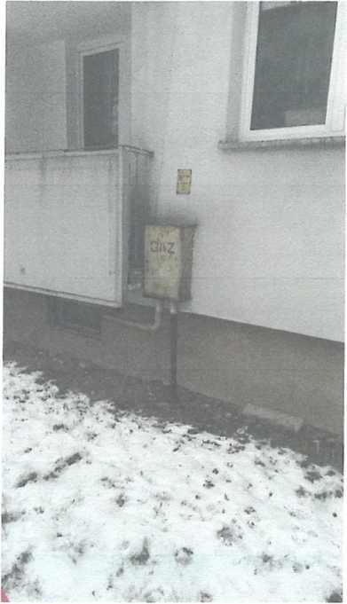

The main gas valve is located on the back outdoor elevation of the building on the level of the

gas boiler room.

1. The principles of use of the hand firefighting equipment and the indoor hydrants

The building is protected with the help of hand firefighting equipment in the form of fire extinguisher of the following types:

* dry-powder extinguisher DP 4x ABC, DP 6xABC

**D**ry-powder extinguishers DP4x ABC and DP6x ABC

The DP 4x ABC and DP 6x ABC dry-powder extinguishers are cylindrical tanks equipped with a lever triggering the pressure gas vale. The extinguishing medium (powder) is discharged with the use of an indifferent gas (Nitrogen) through a discharge nozzle or a discharge hose topped with a nozzle. After the fire extinguisher has been brought to the fire location, the operator needs to pull the seal and the safety pin, push the lever and direct the powder stream into the fire. The discharge of the extinguishing medium may be stopped by releasing the extinguisher lever or the nozzle lever. Due to the fact that has the form of a syphon, the fire extinguisher can work properly only in a vertical position.

DP 4x ABC and DP 6x ABC dry-powder extinguishers are intended for:

* A-class fires (with incandescent burning of wood, paper, cardboard etc.),
* for B-class fires (flammable liquids and melting solids, like: gasoline, alcohol, oil, grease, varnish, solvents, thermoplastic materials, etc.),
* for C-class fires (burning gases such as: propane-butane, acetylene, natural gas).

These fire extinguishers may be used to extinguish fire of the abovementioned groups of materials even if close to electrical devices with the voltage of up to 1000 V provided that the distance of at least 1.5 from the materials is preserved.

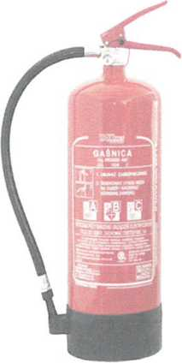

DP4x ABC dry-powder extinguisher

PLEASE NOTE: Fire extinguishers are pressure equipment and if used incorrectly may constitute a life or health hazard; therefore, the operators should know how to use the hand fire safety equipment and should be informed about the hazards which may result from inaccurate use of the equipment. Carbon-dioxide extinguishers shall not be used on persons. It is recommended that fire extinguishers are fixed on hangers intended for this purpose. The safety pin should be pulled out only if the fire extinguisher is to be used. If a seal or safety pin is found missing on a fire extinguisher the equipment needs to be inspected at a licensed maintenance provider’s.

PLEASE NOTE: When extinguishing fire on live electrical devices, it is absolutely necessary to follow the information and recommendations specified on the fire extinguisher’s tag. Protect the fire extinguisher from exposure to unfavourable atmospheric and chemical factors. If the fire extinguisher is used in an enclosed area, the discharged powder needs to be vacuum cleaned and the area needs to be washed with clean water. The warranty and maintenance terms and conditions are consistent with the recommendations on the tag.

The locations of the fire extinguishers on the building’s premises have been marked with fire safety signs.

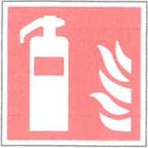

|  |  |  |
| --- | --- | --- |
|  |  | |
| Extinguish fire in the direction of the wind (with the wind).  To extinguish fire on surfaces, begin from the edge. | GOOD | WRONG |
|  |  |
|  |  |
| To extinguish dropping or liquid substances, direct the stream from the top to the bottom  To extinguish walls on fire, direct the stream from the bottom to the top  Use the sufficient number of extinguishers at one time - never one after the other |  |  |
|  |  |
|  |  |
|  |  |
| Make sure that the fire does not start again |  |  |
|  |  |
| Never hang the used fire extinguishers back to their place |  |  |
|  |  |
|  |  | |

When extinguishing fire follow the rules set out below:

* direct the stream of the extinguishing medium on the items or constructions on fire from their outermost side to the inside;
* when extinguishing vertical items on fire, start from the top and go to the bottom; use the extinguishing medium intended for the given fire class;
* when extinguishing fire in rooms, caution needs to be take when opening the doors or smashing the windows, as the fire and hot fumes leaving the hot rooms, may cause serious burns and inflammation of clothing

If the use of the indoor hydrants is required, follow the rules set out below:

* water is a safe and efficient extinguishing medium for A-class fires (with incandescent burning of wood, paper, etc.),

It is prohibited to use water to extinguish:

* fire on combustible materials in the area of live electrical devices,
* fire on flammable liquids lighter than water, i.e. oils, gasoline, kerosene,
* fire on materials with which water interacts chemically, i.e. sodium, calcium, potassium, carbide,
* fire on materials burning in high temperatures, like: magnesium, electron, aluminium. Indoor hydrant user’s instruction
* break the glass protecting the key to the cabinet,
* open the hydrant cabinet with the key,
* take the fire hose nozzle and unwind the hose,
* open the hydrant valve,
* operate the nozzle as shown by the marks (broken stream, solid stream or fog stream),
* direct the water stream onto the fire source,
* after the work has been finished, wind the hose back on the reel and put back into the cabinet.

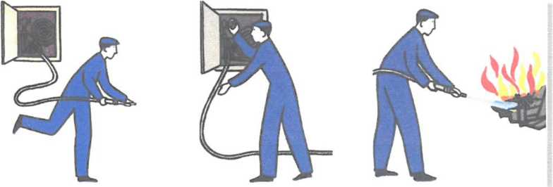

Please note!

The indoor hydrant fire hose line shall not hinder the evacuation of the staff from the building.

For flammable liquids on fire, use fog streams. Such a stream is obtained by appropriate adjustment of the indoor fire hose nozzle.



INDOOR HYDRANT 25

The locations of the indoor hydrants on the building’s premises have been marked with fire safety signs.

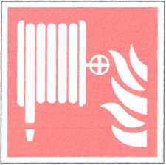

CHAPTER VII.

EVACUATION ORGANISATION AND THE PRACTICAL MEANS OF CONTROLLING IT

Evacuation in its nature is an organised event, therefore the knowledge of its rules and the development of the practical abilities belong to the basic problems of evacuation security. In a situation of a life or health hazard, the activities of the staff should be far from being improvised, incidental or panic-driven. In a situation of stress resulting from a sudden, dangerous incident, the capability of performing rational acts becomes limited to a significant degree; therefore the actions of the staff and tenants of the building undertaken before the arrival of the fire squads are performed in accordance with the given, pre-determined procedures.

1. EVACUATION ORGANISATION

1.1. Recommendations for the persons organising evacuation.

1. The following persons are responsible for the evacuation of persons present on the premises of the building in the event of fire or other local hazard before the arrival of the fire and rescue squads of the State Fire Service:

- the Student’s Dormitory ADMINISTATOR

- the person in charge of the staff members during the absence of the Student’s Dormitory Manager,

- the reception officer: in the afternoon and at night.

The person in charge of the operation precisely determines the location of the fire, its propagation routes, the risk for the tenants, the accessibility of the emergency evacuation routes. Afterwards, he/she makes a decision regarding the scope of evacuation.

1. All other persons present on the building’s premises are obliged to follow the leader’s instructions with no exceptions and to perform their orders.
2. In the case of an alarm, panic must be prevented by all means.
3. It is necessary to determine the ways, sequence and manner of evacuation and protection of the property,
4. People need to be evacuated in the following sequence:

* persons with limited movement capabilities,
* persons from the endangered part of the building or persons who are in the way of the hazard,
* persons from the other parts of the building for whom the access to the safe emergency evacuation routes may be shut off (by smoke or smoke concentration).

1. If it is not known whether all persons have left the endangered building or grounds, this fact needs to be immediately reported to the commander of the Fire and Rescue squad who arrived at the operation site.
2. If the State Fire Service squad arrives in the course of evacuation, the person in charge of the operation is obliged to give the State Fire Service squad commander concise information about the course of the operation and follow the commander's orders.

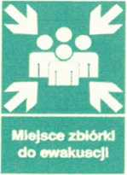1.2. Automatic smoke vents in the staircase

**EMERGENCY ASSEMBLY POINT**

The marking of the emergency assembly points

If the gravity smoke vent system in the staircase fails to activate automatically, it needs to be activated manually by pushing the smoke vent button (the buttons are located on the staircases of the ground floor and the floors no. II and V).

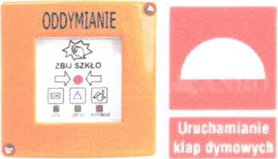

The manual smoke vent button in the stairwell marked as required by fire safety regulations.

The purpose of the proper operation of the staircase smoke vent system is the inlet of air for ventilation. This is achieved by the opening of the emergency exit door at the bottom of the staircase and blocking them in the open position.

All staircases in the building on all over ground storeys are separated from the evacuation corridors with Sa and Sm class smoke-proof doors. The doors are held in the open position by a system of electromagnetic locks controlled by smoke exhaust control units (when the detector detects smoke within the staircase, the control unit cuts off the power supply for the locks and the door closers close the doors.)

If the smoke-proof door fails to close automatically in the smoke-filled staircase, the electromagnetic locks, which hold the door open, need to be released manually by pushing a button located on the body of the lock.

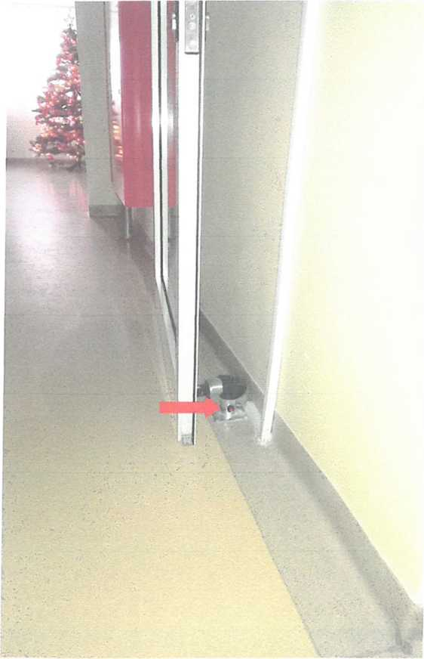

**Please note**

A power cut will result in the activation of the emergency lighting system.

If a decision to evacuate property is made, the following needs to be observed:

The decision to evacuate property is made by the person in charge of evacuation or by the staff organising evacuation, if:

* property of significant value is at risk and it is the only way to save it,
* the property hinders access to the fire source or enhances the flame propagation,
* it is necessary to evacuate (free) people.

Property must not be evacuated at the expense of measures necessary to rescue and evacuate people.

1. Practical verification of the evacuation organisation and conditions.

In accordance with § 17 of the Regulation of the Minister of Internal Affairs and Administration of 07 June 2010 on the fire protection of buildings, other building constructions and grounds ( Journal of Laws Dz.U. 2010, no. 109, item 719) the owner or administrator of structures in which a group of over 50 occupants changes simultaneously and regularly, including: schools, nurseries, boarding houses or student dormitories, is obliged to verify the practical aspects of the organisation and conditions of evacuation at least once a year and no later than 3 months from the moment new occupants have begun using the structure.

The owner or administrator of the structure informs the Municipal Fire Service Chef of the State Fire Service in Bielsko-Biała about the date of the evacuation drill mentioned above no later than one week before it is conducted.

The basic way to verify if the structure occupants and staff are prepared to evacuate effectively and safely is fire drill which enables verification of the following:

* if the fire wardens know their obligations,
* if the evacuation devices are operational,
* if the alarm raising and hazard notification system is operational and functional,
* if there are any potential congestion spots on the evacuation routes,
* if there are any obstacles on the evacuation routes,
* if the functionality and assumptions of the adopted people and property evacuation system are correct.

Evacuation drill principles.

A practical evacuation drill consists in:

* reminding the occupants of the evacuation principles in the form of a training,
* providing or drawing up instructions,
* revising the evacuation plan,
* determination of the evacuation drill date,
* selection of the part of the structure in which evacuation will be conducted,
* appointment of a group of persons who will assess the individual sites and stages of evacuation,
* notification of the relevant State Fire Service headquarters about the date and place of the evacuation drill,
* discussing the results of the evacuation drill with the staff,
* drawing conclusions, making comments and developing a corrective and preventive action plan by the persons who conducted the assessment,
* implementation of the corrective and preventive action plan by the persons in charge.

1. Communicate the fire alarm for the selected part of the building or the entire building.
2. The person who has noticed fire, informs the reception officer about the incident.
3. The reception officer notifies the Fire Service on the phone (mock phone call) and begins to call the fire wardens in accordance with the call tree.
4. The persons in charge of the evacuation of occupants from the individual parts of the structure, make sure that the evacuation is smooth and effective and that there are no persons left for whom the access to evacuation routes has been shut off.
5. The appointed person shuts off the power or gas supply (mock shut off).
6. The evacuated groups of occupants make their way to the evacuation assembly points.

During the drill the following needs to be kept in mind:

a/ the principles of moving around the building in the case of evacuation:

* the running ban,
* the necessity to remain calm,
* bending forward when in smoke-filled spaces,
* moving along the walls in accordance with the evacuation signs placed on the walls.

b/ knowledge of the following by the fire wardens and the staff:

* the plan of the building, the passageways and the directions of emergency routes and exits,
* the distribution of the alarm devices and the alarm rules,
* the location of the keys to the rooms including the spare keys,
* the location of the alarm means (manual call point),
* the location of the emergency power off button and the gas valve.

The practical verification of the evacuation organisation and conditions needs to be followed by documentation describing its course and including the recommendations whose purpose it is to improve the organisation of evacuation.

**CHAPTER VIII**

INSTRUCTION FOR WORKS INVOLVING FIRE HAZARD

The purpose of the instruction is to limit the number of fires which originate as a result of works which involve fire hazard, by indicating the basic fire safety requirements for such works performed during the renovations of the building, the systems and equipment.

Works involving fire hazard are unlikely to be conducted during the regular use of the structure. Such works may be conducted during renovations or repairs.

The works involving fire hazard include in particular:

1. all works which involve open fire, during which sparking or heating occurs, e.g.:

* welding, gas cutting and plasma cutting,
* preheating of systems, devices and valves with flammable substances,
* preheating of asphalt binder, tar, etc.,
* lighting bonfires,
* using pyrotechnic materials.

1. All works which involve the use of liquids, gases and dusts in the presence of which explosive mixtures may originate:

* preparation for the use of gases, dusts and liquids,
* using the dusts and liquids for the purpose of painting, varnishing, gluing,
* washing, saturating,
* removal of the remains of these substances from the work stations.

1. Before the works involving fire hazard begin, the Owner is obliged to:

* assess the fire hazard in the location where the works will be conducted,
* determine the type of measures planned to prevent outbreak or propagation of fire or explosion,
* indicate the persons responsible for the proper preparation of the work site, for the course of the works and for securing the site after the end of work,
* provide only the persons holding the required permits and licenses to perform the works,
* brief the persons performing the works on the fire hazard on the work site and on the preventive measures whose purpose is to prevent outbreak of fire or explosion.

Issuing permits to perform works in places which involve fire hazards:

* The permit to perform works in places which involve fire hazards is issued by the Structure’s Owner after a prior assessment of the fire protection of the work site; in the case of a negative opinion on the fire safety protection, no permit to perform such works is issued.
* In the case of a failure or the so-called force majeure condition, it is permitted to begin the works and to issue the permit without any assessment of the fire protection measures, under the condition, however, that the possible protection measures are applied to their full extent and personal responsibility is taken for them.

1. Organisation rules for the determination of the fire protection measures for the works which involve fire risk
2. The WORKS WHICH INVOLVE FIRE RISK may be conducted on the premises of the structure provided that the fire safety requirements valid before, during and after the works have been met. The requirements mentioned below are determined on the basis of this instruction and the relevant specific regulations by a designated committee each time before the beginning of the works.
3. THE COMMITTEE CONSISTS OF:

* the Building’s Manager - Committee Chairperson
* the Manager of the group (contractor) performing the works - Committee Member.

The Committee may include the necessary specialists at the motion of the Chairperson. The works of the Committee are organised by its Chairperson. The Committee summarizes its work in the “Record of protection measures for works involving fire hazard” (Protokół zabezpieczenia prac pożarowo-niebezpiecznych”.)

After the protection measures determined by the abovementioned Record have been adopted, the Chairperson issues a written “Permit to carry out works involving fire hazard” (Zezwolenie na rozpoczęcie prac niebezpiecznych pożarowo), in accordance with the predetermined form.

Having obtained a written confirmation of the accomplishment of works from the contractor and a confirmation of a positive result of the fire security audit of the work site from the appointed person or persons, the Chairperson performs the technical acceptance of the works in the Record by making the relevant entry in the permit mentioned above.

The Chairperson’s obligations include: the organisation of and providing supervision for the work site; and after the completion of the works in accordance with the “Record of protection measures for works involving fire hazard”, the Chairperson ensures the supervision of the work site by adequately qualified persons.

After the works have been completed, the entire documentation is filed with the technical documentation of the structure.

1. Obligations of the persons connected with the works involving fire hazard

The Structure Owner or the person authorised by them to supervise the course of the works involving fire hazard should in particular:

* know the effective fire safety regulations and supervise the observance of these regulations by their subordinate staff,
* make sure that all recommendations regarding the structure’s or site’s protection set forth in the “Record of protection measures” or in the “Permit” have been met before the works involving fire hazard begin,
* inspect the fire safety measures adopted on the work stations involving fire hazard and issue the adequate orders to guarantee the immediate remedy of any shortcomings found,
* put the works on hold from the moment it has been found that there is a fire-hazard-presenting situation until the time the irregularity has been removed,
* participate in the control of the work stations, rooms or grounds after the completion of the works involving fire hazard.

The obligations of the party performing the works involving fire hazard include in particular:

* making sure that the equipment and tools are operational and duly secured from the possibility of initiating or propagating fire,
* strict observance of the recommendations set out in the Record and Permit,
* the knowledge of the fire safety regulations, the ability to use the hand firefighting equipment and the knowledge of the fire procedures,
* making sure that all fire precautions determined for the individual works have been adopted before the works begin,
* strict observance of the fire precautions determined for the individual works involving fire hazard,
* making sure that the work site has been equipped with the adequate quantity and type of hand firefighting equipment before the beginning of the works,
* the works involving fire hazard begin only after a written permit has been obtained or, alternatively, at the explicit order of the line manager supervising the works,
* briefing the operatives on the fire safety requirements for the performed works involving fire hazard,
* putting the works on hold in the case of a situation or conditions which may enhance the outbreak or propagation of fire and reporting the incident to the line manager,
* informing the line manager about the accomplishment of the works involving fire hazard and of any instances when fire was initiated and extinguished during the works or activities involving fire hazard,
* thorough verification of the work site and its surroundings after the accomplishment of the works, to find whether no fire was initiated during the works involving fire hazard and if all instructions made by the line managers and the control authorities in connection with the fire precautions for the works involving fire hazard, were followed.

1. Rules for the works involving fire hazard

When performing works involving fire hazard, the following rules need to be observed:

* There should be equipment at the work site suitable for the eradication of all fire sources.
* All combustible materials need to be removed from the building, rooms or places where the works involving fire hazard are to be conducted.
* Combustible items or non-combustible items in combustible packaging need to be moved aside from the Work site to a distance of at least 10 m.
* Before the Works begin, it is necessary to verify whether there are any materials or items in the neighbouring rooms which could inflame as a result of heat conduction or spatter.
* The pass-through openings, system or cable holes, etc. close to the Work site, if any, need to be sealed with non-combustible materials to prevent the spatters (e.g. welding spatters) from passing through to the other rooms or storeys.
* All cables, electrical, gas and system conductors with flammable insulation should be secured from exposure to fire and from mechanical damage.
* It is prohibited to perform the Works in rooms in which painting or other works with the use of flammable substances were conducted on the same day (this concerns varnishes and highly flammable paints).
* Special precautions need to be adopted in the buildings or in the rooms with flammable structural components or interior decoration.
* When performing the Works, it is important to verify whether the metal structures or other elements exposed to open fire do not come into direct contact with the combustible parts of the construction and whether the materials in the neighbouring rooms will not inflame as a result of heat conduction.
* The works involving fire hazard may be performed only by authorised persons with relevant qualifications and holding adequate licenses.
* The equipment used to conduct works involving fire hazard must be operational and secured in such a way that it does not cause fire.

1. “Record of protection measures for works involving fire hazard” (Protokół zabezpieczenia prac pożarowo-niebezpiecznych”.)
2. “Permit to carry out works involving fire hazard” form ( wzór Zezwolenia na rozpoczęcie prac niebezpiecznych pożarowo)
3. Log book of works involving fire hazard (Książka prowadzenia prac niebezpiecznych pożarowo)

Record

of protection measures for works involving fire hazard

1. Name and description of the building, room and place in which it is planned to conduct the works involving fire hazard, date and time of the beginning of the works
2. Human-related hazard class, explosion hazard and the fire properties of the combustible materials present in the building or the room
3. The type of construction elements (inflammability) present in the given building, room or site of the planned works
4. Fire preventive measures adopted in the building, room, work station of a device, etc., for the time of the works
5. Number and type of the hand firefighting equipment for securing the works
6. Ways and means of alarming Fire Service and the co-workers in the event of fire
7. Person in charge of the preparation and implementation of the security measures for the works involving fire hazard
8. Person responsible for supervising fire safety in the course of the works involving fire hazard
9. Persons obliged to inspect the area of the works involving fire hazard after their completion
10. Signatures of Committee Members

(Surname, Name, name of position)

|  |  |  |  |  |  |
| --- | --- | --- | --- | --- | --- |
|  | | PERMIT No. /2016  to carry out works involving fire hazard | | | |
| 1. Type of work: |  | | | | |
|  | | | | | |
|  | | | | | |
|  |  | | | | |
| 2. Work site: |  | | | | |
|  | | | | | |
|  |  | |  |  |  |
| 3. Time of work: | date: | | time from: | time to: |  |
|  |  | |  |  |  |
|  | | | |  | |
| 4. Fire/ explosion hazard on the site: | | | |  | |
|  | | | | | |
|  | | | | | |
|  | | | | |  |
| 5. Precautions taken to prevent outbreak of fire/ explosion: | | | | |  |
|  | | | | | |
|  | | | | | |
|  | | | | | |
|  | | |  |  |  |
| 6. Protection measures: | | |  |  |  |
|  |  | |  |  |  |
| Fire protection: |  | | | | |
|  | | | | | |
| H&S: |  | | | | |
|  | | | | | |
|  | | | | | |
| Other: |  | | | | |
|  | | | | | |
|  | | | | | |
|  | | |  |  |  |
| 7. Person responsible for the course of works: | | |  |  |  |
| Preparation of the site, protection measures: | | | |  |  |
|  |  | |  | (Name and Surname) | (signature) |
|  |  | |  |  |  |
| 8. I grant permission to begin the works | | |  |  |  |
|  |  | |  | (Name and Surname, signature) |  |
|  |  | |  |  |  |
| 9. Work accomplished: | | | date: | time: |  |
|  |  | |  |  |  |
| 10. Work station and its surroundings have been verified, no act or omission has been detected which might cause fire | | | | | |
|  | after the completion of the works: | | |  |  |
|  |  | | | (Name and Surname) | (signature) |
|  | after from the completion of the works: | | |  |  |
|  |  | | | (Name and Surname) | (signature) |

|  |  |  |  |  |  |  |
| --- | --- | --- | --- | --- | --- | --- |
|  | | REGISTER OF WORKS INVOLVING FIRE HAZARD | | | | |
|  | Work site | Date | Work performed by | Person responsible for the work | Permit issued by | Notes |
| 1. |  |  |  |  |  |  |
| 2. |  |  |  |  |  |  |
| 3 |  |  |  |  |  |  |
| 4. |  |  |  |  |  |  |
| 5. |  |  |  |  |  |  |
| 6. |  |  |  |  |  |  |
| 7. |  |  |  |  |  |  |
| 8. |  |  |  |  |  |  |
| 9. |  |  |  |  |  |  |
| 10. |  |  |  |  |  |  |
| 11. |  |  |  |  |  |  |
| 12. |  |  |  |  |  |  |
| 13. |  |  |  |  |  |  |
| 14. |  |  |  |  |  |  |
| 15. |  |  |  |  |  |  |

Schedule 3

CHAPTER IX

PRINCIPLES OF BRIEFING THE STAFF MEMBERS ON THE FIRE PROTECTION REGULATIONS AND THE FIRE SAFETY INSTRUCTION

The effectiveness of the implemented protection system depends on the proper preparation of staff members to perform the required activities. The scope of preparation should include in particular the knowledge of this instruction, including in particular the distribution of the fire safety devices, the alarm means, fire extinguishers and hydrants, how and when to use them and the knowledge of the procedures for fire or other local alarm, for notifying the rescue services and conducting evacuation from the individual rooms and the entire structure.

The staff working in the building shall be briefed on the fire safety instruction within a month from its effective date, and the new employees on their first day of work; the briefing should be confirmed by a written statement, as set forth in chapter IX. The statement shall be kept in the employee’s personal file.

The purpose of the training is to raise awareness of all staff members in connection to fire safety and to implement the procedures for preventing outbreak of fire and other local hazards, as well as to brief the staff members of the procedure for an existing hazard in the building. The training should be attended by all staff members and should be composed of two stages:

* Stage 1: introduction - organised during the process of employment,
* Stage 2: basic training - organised no later than 6 months from the first day of employment.

The periodical trainings should be conducted at least once in 3 years for the operative employees and at least once in 6 years for office staff and the Management. It is recommended to conduct such trainings in connection with health and safety trainings. The training needs to be repeated each time after any material technical or organisational changes have been implemented or if it has been found that the staff members do not have sufficient knowledge of the issues in question. The organisation of staff trainings in respect of the fire safety procedures is the responsibility of the employer.

The training should be followed by an exam and both should be confirmed with a certificate which should be kept on the employee's personal file. The trainings on fire safety should be conducted by persons who have good knowledge of the field and have the necessary qualifications set forth in the Regulation of the Minister of Internal Affairs and Administration of 08 December 1998 on the requirements regarding the professional qualifications and the requirements regarding the psychological and physical condition of persons working in fire service units, and regarding the professional qualifications of other persons who perform fire safety activities. (Journal of Laws Dz. U. 2010, no 159, item 1050).

The table below presents a draft of the basic (periodical) training programme:

|  |  |  |
| --- | --- | --- |
| 1. | Fire hazard components Causes of outbreak and propagation of fire | 1 hour |
| 2. | Fire safety tasks and obligations of staff members | 1 hour |
| 3. | Staff members’ tasks and obligations in the event of fire or other hazard | 1 hour |
| 4. | Evacuation of persons, evacuation routes and means | 1 hour |
| 5. | Firefighting equipment and fire safety devices | 1 hour |

Training records

Every training should be put on record as required.

An integral part of the training is a practical hands on use of selected firefighting equipment.

The training records should include:

* the training programme,
* the attendance list,
* the employee’s statement confirming that they have acquired knowledge of the fire safety regulations,
* a copy of the certificate issued to the training participants.

Date:

STATEMENT NO. .....

regarding completion of the introduction training

I, the undersigned with my place of work in……………….

state that I have participated in the introduction training on fire safety, during which I was briefed on the “Fire Safety Instruction” for the Structure's premises, including in particular the following issues:

* Fire hazard in the structure,
* General causes of outbreaks of fire and flame propagation,
* Fire safety tasks and obligations of staff members,
* Ways to communicate a fire alarm and the fire emergency procedures,
* Evacuation principles,
* Recommended practice regarding materials which involve fire hazard,
* The use of the hand firefighting equipment available on the structure’s premises.

I understand the abovementioned rules and principles and shall abide by them.

(Signature of the party accepting the statement)

(Employee signature)

LEGAL REGULATIONS

1. Act of 24 August 1991 on fire safety (Journal of Laws Dz. U. 2002 no. 147, item 1229, as amended).
2. Act of 07 July 1994 - Construction Law (Journal of Laws Dz.U. no. 89, item 414, as amended).
3. Regulation of the Minister of Internal Affairs and Administration of 07 June 2010 on the fire protection of buildings, other building constructions and grounds (Journal of Laws Dz. U. no 109, item 719).
4. Regulation of the Minister of Infrastructure of 12 April 2002 on the technical specifications of buildings and their situation (Journal of laws Dz.U. 2010, no. 75, item 690).
5. Regulation of the Minister of Internal Affairs and Administration of 24 July 2009 on water supply for fire protection and fire service access roads (Journal of Laws Dz. U. no. 124, item 1030).
6. Regulation of the Minister of Internal Affairs and Administration of 08 December 1998 on the requirements regarding the professional qualifications and the requirements regarding the psychological and physical condition of persons working in fire service units, and regarding the professional qualifications of other persons who perform fire safety activities. (Journal of Laws Dz. U. no. 159, item 1050).

SCHEDULES



Schedule 1

SITE PLAN

FIRE SAFETY INSTRUCTION

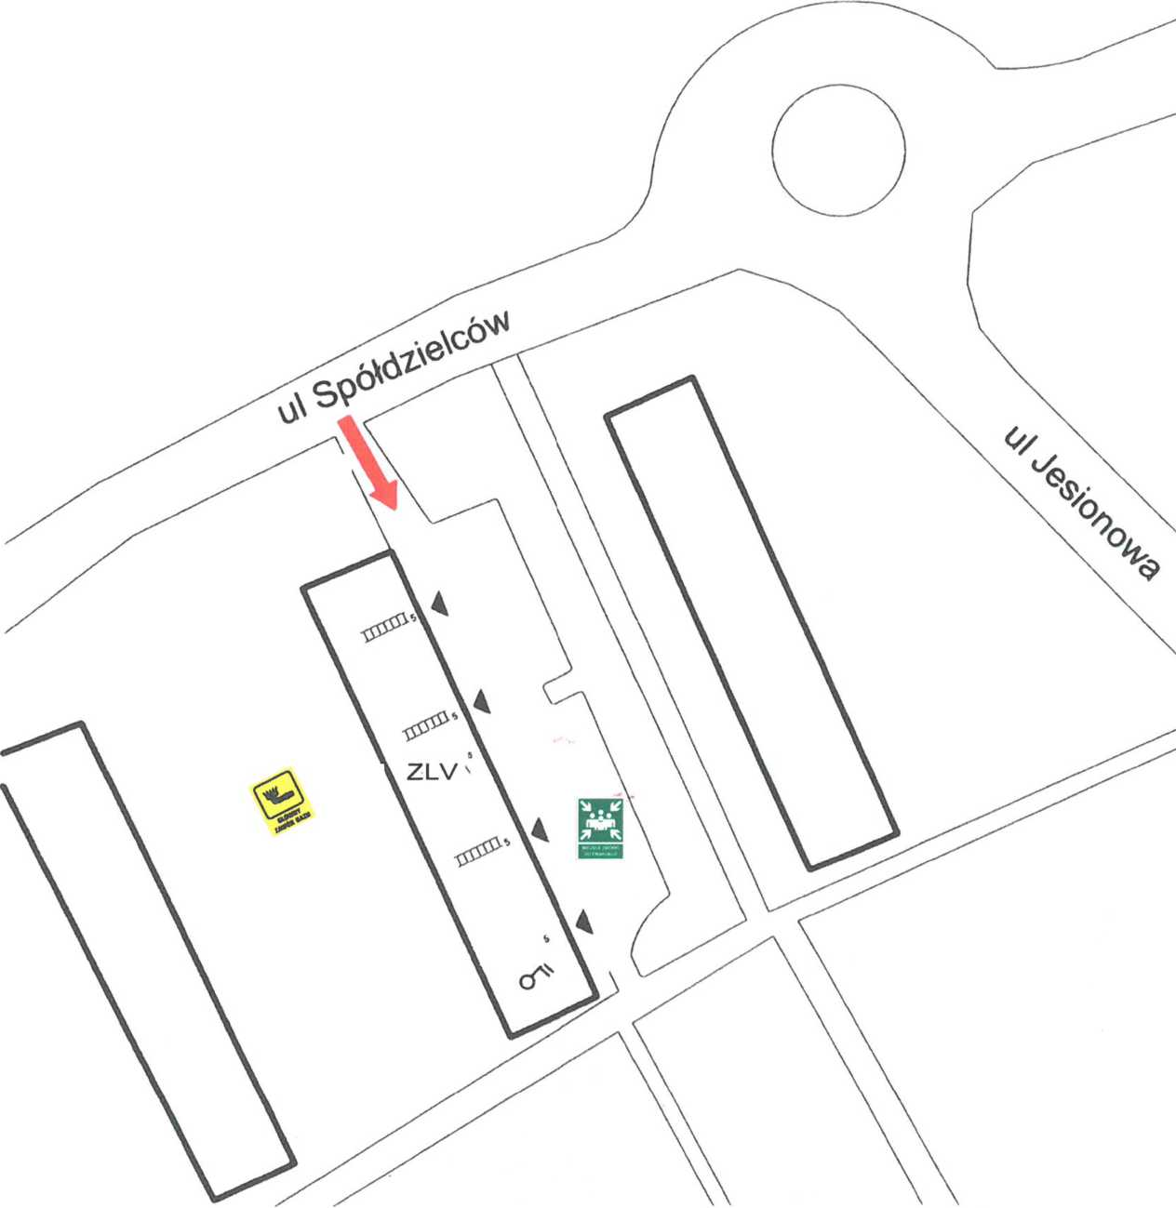

|  |  |  |
| --- | --- | --- |
| Structure name: | Investor: |  |
| STUDENT’S DORMITORY 2 | Akademia Techniczno-Humanistyczna | |
| 43-300 Bielsko-Biała | 43-309 Bielsko-Biała | |
| ul. Spółdzielców 11 | ul. Willowa 2 | |
| Drawing title | Title: |  |
| SITE PLAN | SCHEDULE 1 | |
| Prepared by: | Drawing **1** | DATE  JANUARY 2016 |
|  |  |  |



-EPO

- Fire Service Access Rd

- Main Gas Valve

* Assembly point after evacuation

Key:

► emergency exit from building

ZLV – HHC – Human Related Hazard Cat.

* - stairs to storey V
* - 5-storey building



C:\Users\MARIUS~1\AppData\Local\Temp\FineReader12.00\media\image31.jpeg



Schedule 2

EMERGENCY EVACUATION PLAN

AND THE DISTRIBUTION OF THE HAND FIREFIGHTING EQUIPMENT AND FIRE SAFETY DEVICES.

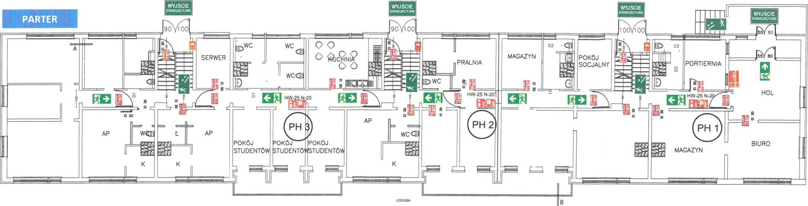

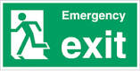







**GROUND FL**

KITCHEN

SERVERER

UTILITY

ROOM

STORE

ROOM

BREAK

ROOM

RECEPT

OFFICE

HALL

WR1

WR2

WR3

B

STUDENT

ROOM

STUDENT

ROOM

OFFICE

STUDENT

ROOM

STORE

ROOM

HYDROPHORE SET

WR1

WR2

DISTRICT

HEATING

SYSTEM

GF

GAS FURNACE

BOILER

AUXILIARY ROOM

AUXILIARY ROOM

AUXILIARY ROOM

AUXILIARY ROOM

AUXILIARY ROOM

**BASEMENT**

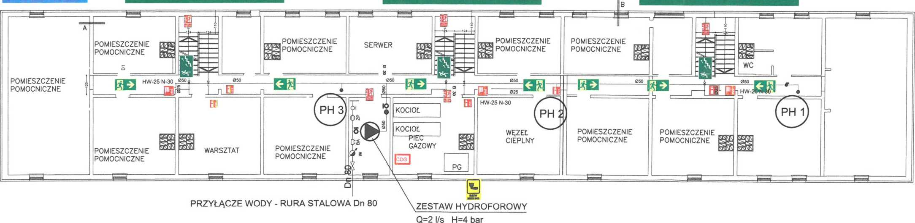

EVACUATION UP THE STAIRS TO THE EMERGENCY EXIT ON THE GROUND FLOOREVACUATION UP THE STAIRS TO THE EMERGENCY EXIT ON THE GROUND FLOOREVACUATION UP THE STAIRS TO THE EMERGENCY EXIT ON THE GROUND FLOOR

WATER CONNECTION – STEEL PIPE DN 80

WR3

BOILER

AUXILIARY ROOM

WORKSHOP

SERVER

AUXILIARY ROOM

AUXILIARY ROOM

AUXILIARY ROOM

C:\Users\MARIUS~1\AppData\Local\Temp\FineReader12.00\media\image34.jpegC:\Users\MARIUS~1\AppData\Local\Temp\FineReader12.00\media\image35.jpeg

EXHAUST VENTS ACTIVATION BUTTON ON THE STAIRCASE

STAIRCASE GRAVITY VENTS SYSTEM CONTROL UNIT

MAIN GAS VALVE

GAS DETECTION CONTROL UNIT

FIRE SEPARATION DOOR



**EMERGENCY**

EXIT

HS X

EMERGENCY EXIT EVACUATIONDIRECTION EPO

FIRE EXTINGUISHER

**P.U.H. „INSTAL-POŻ" s.c.**

Kompleksowe zabezbieczenie p.poż.  
34-300 Żywiec, ul. Ks. Pr. St. Słonki 49  
tel.|fax 033 861 11 14  
tel. 0 502 645 233, 0 502 495 665  
Regon 072268985 NIP 553-21-12-363

|  |  |  |
| --- | --- | --- |
| Structure name:  STUDENT’S DORMITORY 2, 43-300 Bielsko-Biała ul. Spółdzielców 11 | Investor:  Akademia Techniczno-Humanistyczna 43-309 Bielsko-Biała ul. Willowa 2 | |
| Drawing title | Title: |  |
| EVACUATION PLAN, DISTRIBUTION OF FIRE SAFETY AND FIREFIGHTING EQUIPMENT | VIEW OF BASEMENT AND GROUND FLOOR | |
| PREPARED BY: | Drawing 1 | DATE  JANUARY 2016 |



INDOOR HYDRANT 25

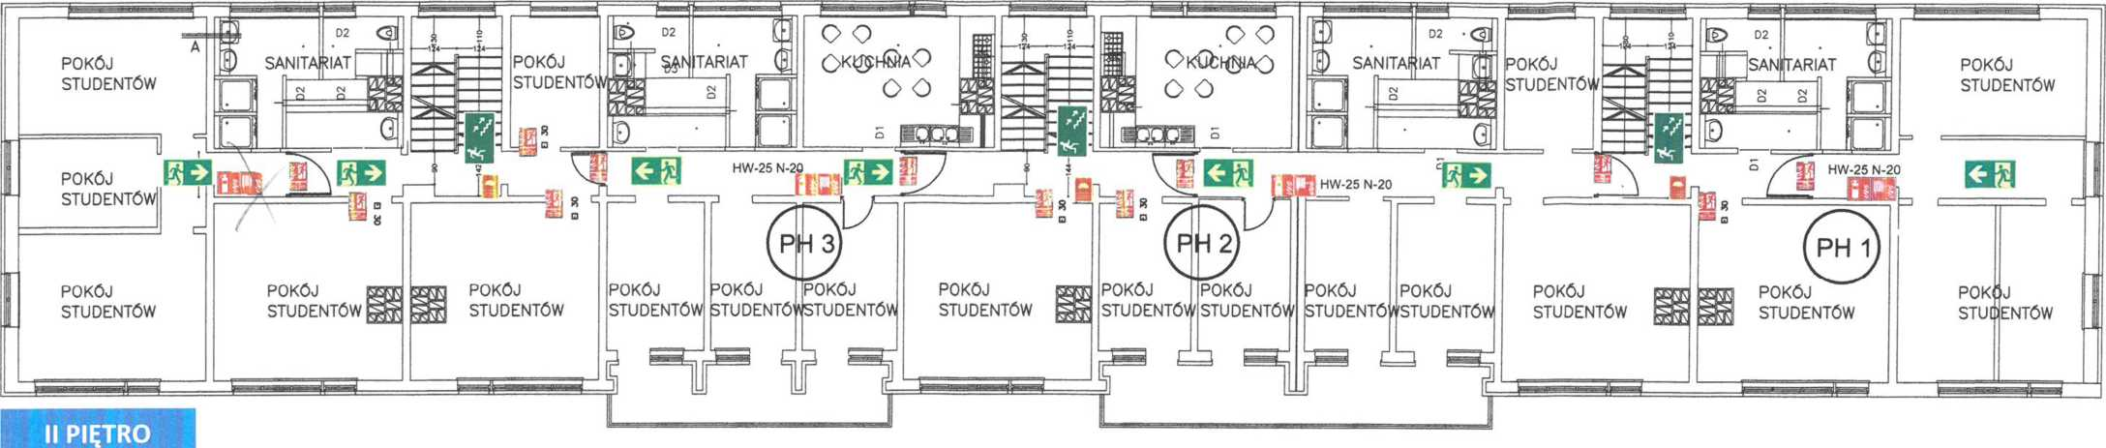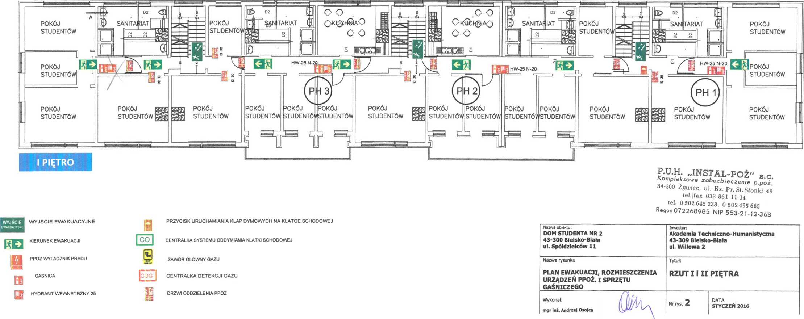

|  |  |  |  |  |
| --- | --- | --- | --- | --- |
| EVACUATION THROUGH THE FIRE-SEPARATED STAIRCASE WITH THE AUTOMATIC GRAVITY VENT SYSTEM TO THE EMERGENCY EXIT ON THE GROUND FLOOR |  | EVACUATION THROUGH THE FIRE-SEPARATED STAIRCASE WITH THE AUTOMATIC GRAVITY VENT SYSTEM TO THE EMERGENCY EXIT ON THE GROUND FLOOR |  | EVACUATION THROUGH THE FIRE-SEPARATED STAIRCASE WITH THE AUTOMATIC GRAVITY VENT SYSTEM TO THE EMERGENCY EXIT ON THE GROUND FLOOR |

|  |  |  |  |  |
| --- | --- | --- | --- | --- |
| EVACUATION THROUGH THE FIRE-SEPARATED STAIRCASE WITH THE AUTOMATIC GRAVITY VENT SYSTEM TO THE EMERGENCY EXIT ON THE GROUND FLOOR |  | EVACUATION THROUGH THE FIRE-SEPARATED STAIRCASE WITH THE AUTOMATIC GRAVITY VENT SYSTEM TO THE EMERGENCY EXIT ON THE GROUND FLOOR |  | EVACUATION THROUGH THE FIRE-SEPARATED STAIRCASE WITH THE AUTOMATIC GRAVITY VENT SYSTEM TO THE EMERGENCY EXIT ON THE GROUND FLOOR |

KITCHEN

KITCHEN

BATHRM

BATHRM

BATHRM

BATHRM

STUDENT ROOM

STUDENT ROOM

STUDENT ROOM

STUDENT ROOM

STUDENT ROOM

WR1

WR2

WR3

STUDENT ROOM

STUDENT ROOM

STUDENT ROOM

STUDENT ROOM

STUDENT ROOM

STUDENT ROOM

STUDENT ROOM

STUDENT ROOM

STUDENT ROOM

STUDENT ROOM

STUDENT ROOM

STUDENT ROOM

STUDENT ROOM

STUDENT ROOM

FLOOR II

BATHRM

BATHRM

BATHRM

BATHRM

STUDENT ROOM

STUDENT ROOM

STUDENT ROOM

KITCHEN

KITCHEN

STUDENT ROOM

STUDENT ROOM

STUDENT ROOM

WR1

WR2

WR3

STUDENT ROOM

STUDENT ROOM

STUDENT ROOM

STUDENT ROOM

STUDENT ROOM

STUDENT ROOM

STUDENT ROOM

STUDENT ROOM

STUDENT ROOM

STUDENT ROOM

STUDENT ROOM

STUDENT ROOM

STUDENT ROOM

STUDENT ROOM

FLOOR I

|  |  |  |
| --- | --- | --- |
| Structure name:  STUDENT’S DORMITORY 2, 43-300 Bielsko-Biała ul. Spółdzielców 11 | Investor:  Akademia Techniczno-Humanistyczna 43-309 Bielsko-Biała ul. Willowa 2 | |
| Drawing title | Title: |  |
| EVACUATION PLAN, DISTRIBUTION OF FIRE SAFETY AND FIREFIGHTING EQUIPMENT | VIEW OF FLOORS I AND II | |
| PREPARED BY: | Drawing 2 | DATE  JANUARY 2016 |

EXHAUST VENTS ACTIVATION BUTTON ON THE STAIRCASE

STAIRCASE GRAVITY VENTS SYSTEM CONTROL UNIT

MAIN GAS VALVE

GAS DETECTION CONTROL UNIT

FIRE SEPARATION DOOR

EMERGENCY EXIT EVACUATIONDIRECTION EPO

FIRE EXTINGUISHER

INDOOR HYDRANT 25

EVACUATION THROUGH THE FIRE-SEPARATED STAIRCASE  
WITH THE AUTOMATIC GRAVITY VENT SYSTEM TO   
THE EMERGENCY EXIT ON THE GROUND FLOOR

EVACUATION THROUGH THE FIRE-SEPARATED STAIRCASE  
WITH THE AUTOMATIC GRAVITY VENT SYSTEM TO   
THE EMERGENCY EXIT ON THE GROUND FLOOR

EVACUATION THROUGH THE FIRE-SEPARATED STAIRCASE  
WITH THE AUTOMATIC GRAVITY VENT SYSTEM TO   
THE EMERGENCY EXIT ON THE GROUND FLOOR

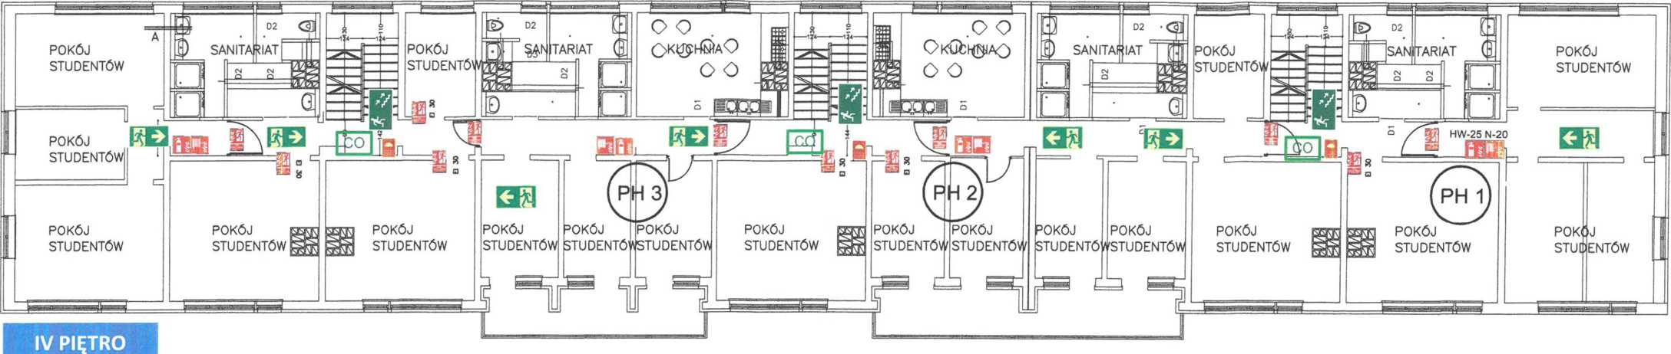

BATHRM

BATHRM

BATHRM

BATHRM

STUDENT ROOM

KITCHEN

KITCHEN

STUDENT ROOM

STUDENT ROOM

STUDENT ROOM

STUDENT ROOM

WR1

WR2

WR3

STUDENT ROOM

STUDENT ROOM

STUDENT ROOM

STUDENT ROOM

STUDENT ROOM

STUDENT ROOM

STUDENT ROOM

STUDENT ROOM

STUDENT ROOM

STUDENT ROOM

STUDENT ROOM

STUDENT ROOM

STUDENT ROOM

STUDENT ROOM

FLOOR IV

|  |  |  |  |  |
| --- | --- | --- | --- | --- |
| EVACUATION THROUGH THE FIRE-SEPARATED STAIRCASE WITH THE AUTOMATIC GRAVITY VENT SYSTEM TO THE EMERGENCY EXIT ON THE GROUND FLOOR |  | EVACUATION THROUGH THE FIRE-SEPARATED STAIRCASE WITH THE AUTOMATIC GRAVITY VENT SYSTEM TO THE EMERGENCY EXIT ON THE GROUND FLOOR |  | EVACUATION THROUGH THE FIRE-SEPARATED STAIRCASE WITH THE AUTOMATIC GRAVITY VENT SYSTEM TO THE EMERGENCY EXIT ON THE GROUND FLOOR |

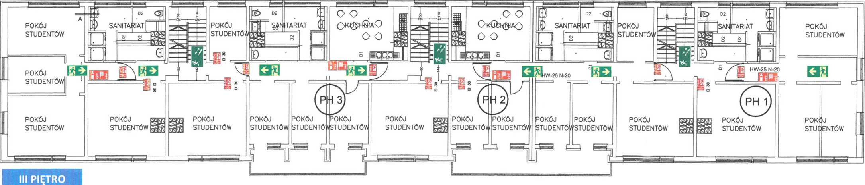C:\Users\MARIUS~1\AppData\Local\Temp\FineReader12.00\media\image41.jpegC:\Users\MARIUS~1\AppData\Local\Temp\FineReader12.00\media\image42.jpegC:\Users\MARIUS~1\AppData\Local\Temp\FineReader12.00\media\image43.jpeg

BATHRM

KITCHEN

KITCHEN

BATHRM

BATHRM

BATHRM

STUDENT ROOM

STUDENT ROOM

STUDENT ROOM

STUDENT ROOM

STUDENT ROOM

WR3

WR2

WR1

STUDENT ROOM

STUDENT ROOM

STUDENT ROOM

STUDENT ROOM

STUDENT ROOM

STUDENT ROOM

STUDENT ROOM

STUDENT ROOM

STUDENT ROOM

STUDENT ROOM

STUDENT ROOM

STUDENT ROOM

STUDENT ROOM

STUDENT ROOM

FLOOR III

tel. 0 502 645 233, 0 502 495 665  
Regon 072268985 NIP 553-21-12-363

|  |  |  |
| --- | --- | --- |
| Structure name:  STUDENT’S DORMITORY 2, 43-300 Bielsko-Biała ul. Spółdzielców 11 | Investor:  Akademia Techniczno-Humanistyczna 43-309 Bielsko-Biała ul. Willowa 2 | |
| Drawing title | Title: |  |
| EVACUATION PLAN, DISTRIBUTION OF FIRE SAFETY AND FIREFIGHTING EQUIPMENT | VIEW OF FLOORS III AND IV | |
| Prepared by: | Drawing 3 | DATE |
|  | JANUARY 2016 |

EXHAUST VENTS ACTIVATION BUTTON ON THE STAIRCASE

STAIRCASE GRAVITY VENTS SYSTEM CONTROL UNIT

MAIN GAS VALVE

GAS DETECTIONCONTROL UNIT FIRE SEPARATION DOORS

EMERGENCY EXIT

EVACUATIONDIRECTION

EPO

FIRE EXTINGUISHER

INDOOR HYDRANT 25





Schedule 3

DISTRIBUTION OF EMERGENCY LIGHTING SYSTEM COMPONENTS.

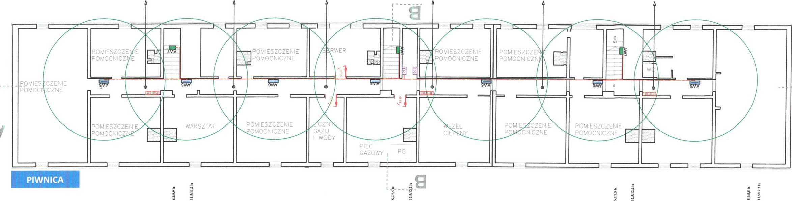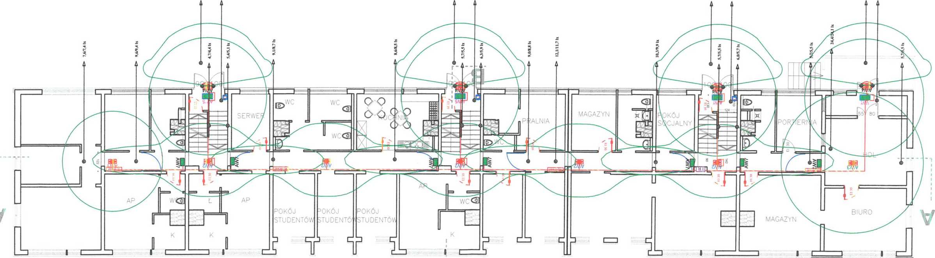

SERVER

AUXILIARY

ROOM

AUXILIARY

ROOM

AUXILIARY

ROOM

AUXILIARY

ROOM

AUXILIARY

ROOM

GAS & WATER CONNECTION

DISTRICT HEATING SYSTEM

WORKSHOP

AUXILIARY

ROOM

AUXILIARY

ROOM

AUXILIARY

ROOM

AUXILIARY

ROOM

PG - GAS FURNACE

BASEMENT

UTILITYROOM

KITCHEN

RECEPTION OFFICE

STORE ROOM

BREAKROOM

SERVER

B

STORE ROOM

STUDENT ROOM

STUDENT ROOM

STUDENT ROOM

OFFICE

P.U.H. „INSTAL-POŻ" s.c.

**GROUND FLOOR**

Kompleksowe zabezbieczenie p.poż.  
 34-300 Żywiec, ul. Ks. Pr. St. Słonki 49  
tel.|fax 033 861 11 14  
tel. 0 502 645 233, 0 502 495 665  
Regon 072268985 NIP 553-21-12-363

KEY:

AW1 - TM Technologie - emergency lighting fitting Ontec S type M1 101 NM AT, ceiling NM (emergency operation), AT (automatic self-test), no pictogram, 7x LED - 1W, 1h, 193 lm/128 Im

AW2 - TM Technologie -emer-cy lighting fitting Ontec S type C1 102 NM AT, ceiling NM (emergency operation), AT (automatic self-test), no pictogram 1x LED - 2.5W, 1h, 204 lm/204 Im

AW3 - TM Technologie -emer-cy lighting fitting Ontec S type M2 102 NM AT, ceiling NM (emergency operation), AT (automatic self-test), no pictogram 14x LED - 2W, 1h, 235 lm/218 Im

AW4 – TM Technologie - emergency lighting fitting Ontec S type W1 302 NM COLD AT, wall NM (emergency operation), AT (automatic test)

C:\Users\MARIUS~1\AppData\Local\Temp\FineReader12.00\media\image46.jpeg

AW5 - Hybryd - emer-cy lighting fitting ALU type LED 4 AT, ceiling dark (emergency operation), AT (automatic self-test) with Emergency exit pictogram, 4x LED - 2 W, 1 h, 193/128 Im

AW6 - Beghelli 2043 emergency lighting fitting after renovation, wall dark (emergency operation), self-test only after power cut 230V 1x 18 W G5 - 3 h

AW7 - Beghelli Formula 65 - existing direction emer-cy lighting fitting with and without pictogram after renovation, wall dark (emer-cy operation), test only after power cut 230V 1x 8 WG5- 3h

YDYp 3x 1,5 mm cable

|  |  |
| --- | --- |
| Structure name: | Investor: |
| STUDENT’S DORMITORY 2 | Akademia Techniczno-Humanistyczna |
| 43-300 Bielsko-Biała | 43-309 Bielsko-Biała |
| ul. Spółdzielców 11 | ul. Willowa 2 |
| Drawing title | Title: |
| Distribution of the emergency lighting system components. | VIEW OF BASEMENT AND GROUND FLOOR |

Prepared by:

Drawing 1

DATE

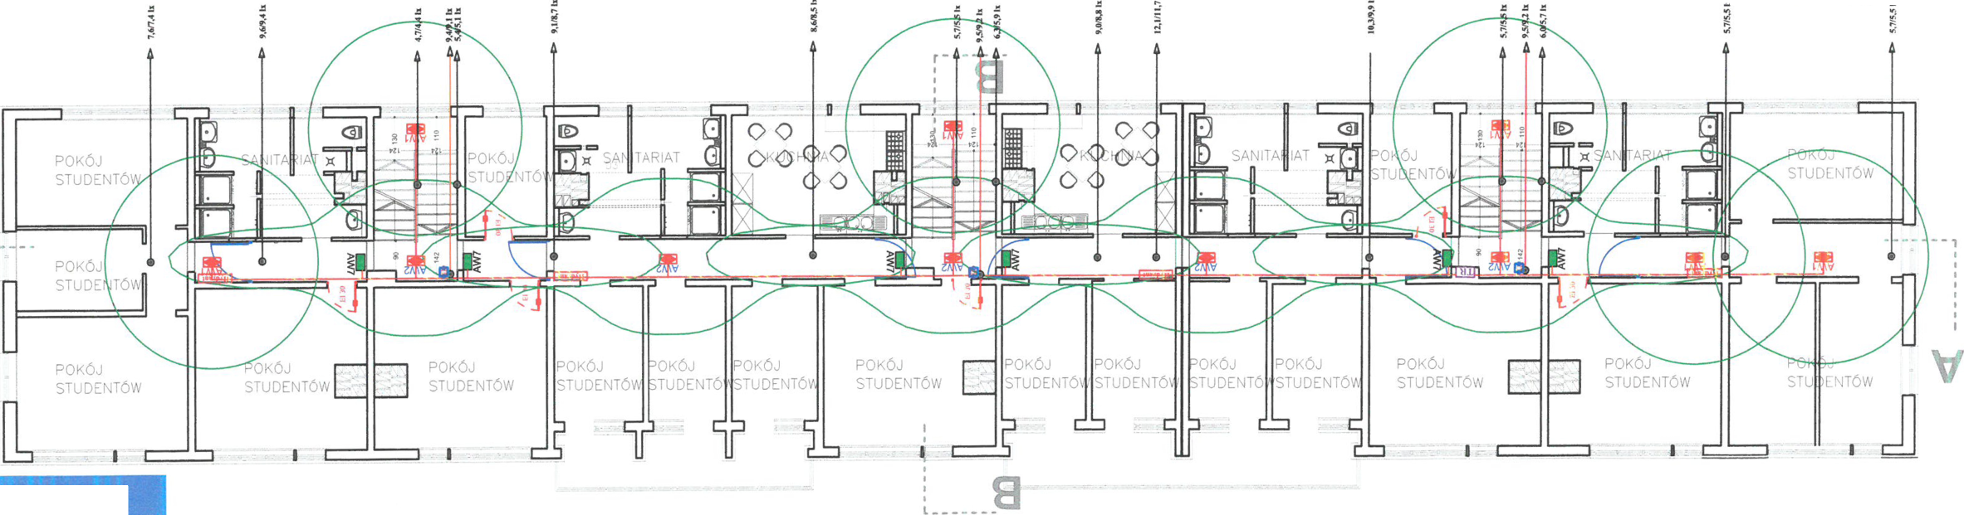Key:



AW1 - TM Technologie - emergency lighting fitting Ontec S type M1 101 NM AT, ceiling NM (emergency operation), AT (automatic self-test), no pictogram, 7x LED - 1W, 1h, 193 lm/128 Im

AW2 - TM Technologie -emer-cy lighting fitting Ontec S type C1 102 NM AT, ceiling NM (emergency operation), AT (automatic self-test), no pictogram 1x LED - 2.5W, 1h, 204 lm/204 Im

AW3 - TM Technologie -emer-cy lighting fitting Ontec S type M2 102 NM AT, ceiling NM (emergency operation), AT (automatic self-test), no pictogram 14x LED - 2W, 1h, 235 lm/218 Im

AW4 – TM Technologie - emergency lighting fitting Ontec S type W1 302 NM COLD AT, wall NM (emergency operation), AT (automatic test)

BATH ROOM

BATH ROOM

STUDENT ROOM

STUDENT ROOM

STUDENT ROOM

STUDENT ROOM

STUDENT ROOM

STUDENT ROOM

STUDENT ROOM

STUDENT ROOM

FLOOR I

KITCHEN

BATH ROOM

BATH ROOM

STUDENT ROOM

STUDENT ROOM

STUDENT ROOM

STUDENT ROOM

STUDENT ROOM

STUDENT ROOM

STUDENT ROOM

STUDENT ROOM

STUDENT ROOM

KITCHEN

KITCHEN

BATH ROOM

BATH ROOM

STUDENT ROOM

STUDENT ROOM

STUDENT ROOM

STUDENT ROOM

STUDENT ROOM

STUDENT ROOM

STUDENT ROOM

STUDENT ROOM

STUDENT ROOM

STUDENT ROOM

STUDENT ROOM

KITCHEN

BATH ROOM

BATH ROOM

STUDENT ROOM

STUDENT ROOM

STUDENT ROOM

STUDENT ROOM

STUDENT ROOM

STUDENT ROOM

STUDENT ROOM

STUDENT ROOM

STUDENT ROOM

STUDENT ROOM

STUDENT ROOM

* 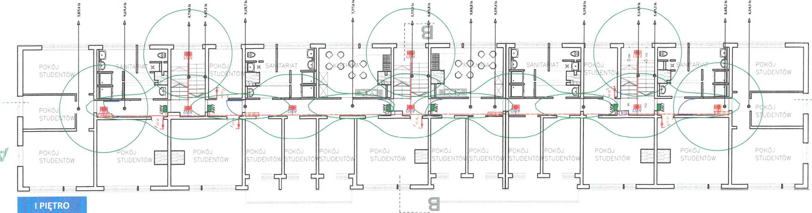-

AW5 - Hybryd - emer-cy lighting fitting ALU type LED 4 AT, ceiling dark (emergency operation), AT (automatic self-test) with Emergency exit pictogram, 4x LED - 2 W, 1 h, 193/128 Im

AW6 - Beghelli 2043 emergency lighting fitting after renovation, wall dark (emergency operation), self-test only after power cut 230V 1x 18 W G5 - 3 h

AW7 - Beghelli Formula 65 - existing direction emer-cy lighting fitting with and without pictogram after renovation, wall dark (emer-cy operation), test only after power cut 230V 1x 8 WG5- 3h

YDYp 3x 1,5 mm cable

|  |  |  |
| --- | --- | --- |
| Structure name: | Investor: |  |
| STUDENT’S DORMITORY 2 | Akademia Techniczno-Humanistyczna | |
| 43-300 Bielsko-Biała | 43-309 Bielsko-Biała | |
| ul. Spółdzielców 11 | ul. Willowa 2 | |
| Drawing title | Title: |  |
| Distribution of the emergency lighting system components. | VIEW OF | FLOORS I AND II |
| Prepared by: | Drawing 2 | DATE  JANUARY 2016 |



P.U.H „INSTAL-POŻ" s.c.

Kompleksowe zabezbieczenie p.poż.  
34-300 Żywiec, ul. Ks. Pr. St. Słonki 49  
tel.|fax 033 861 11 14  
tel. 0 502 645 233, 0 502 495 665  
Regon 072268985 NIP 553-21-12-363

**FLOOR II**

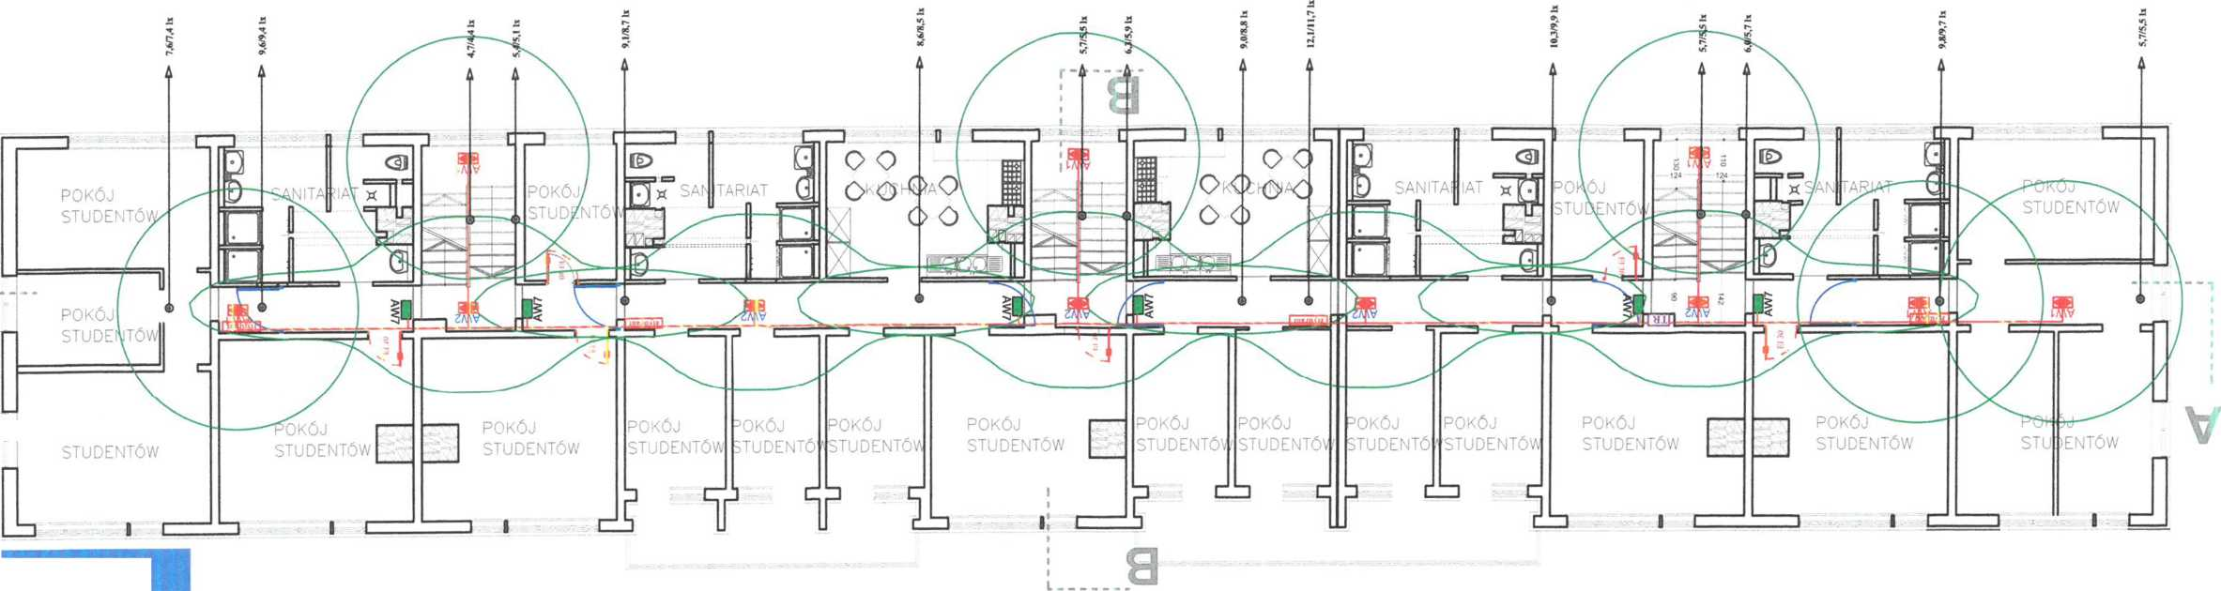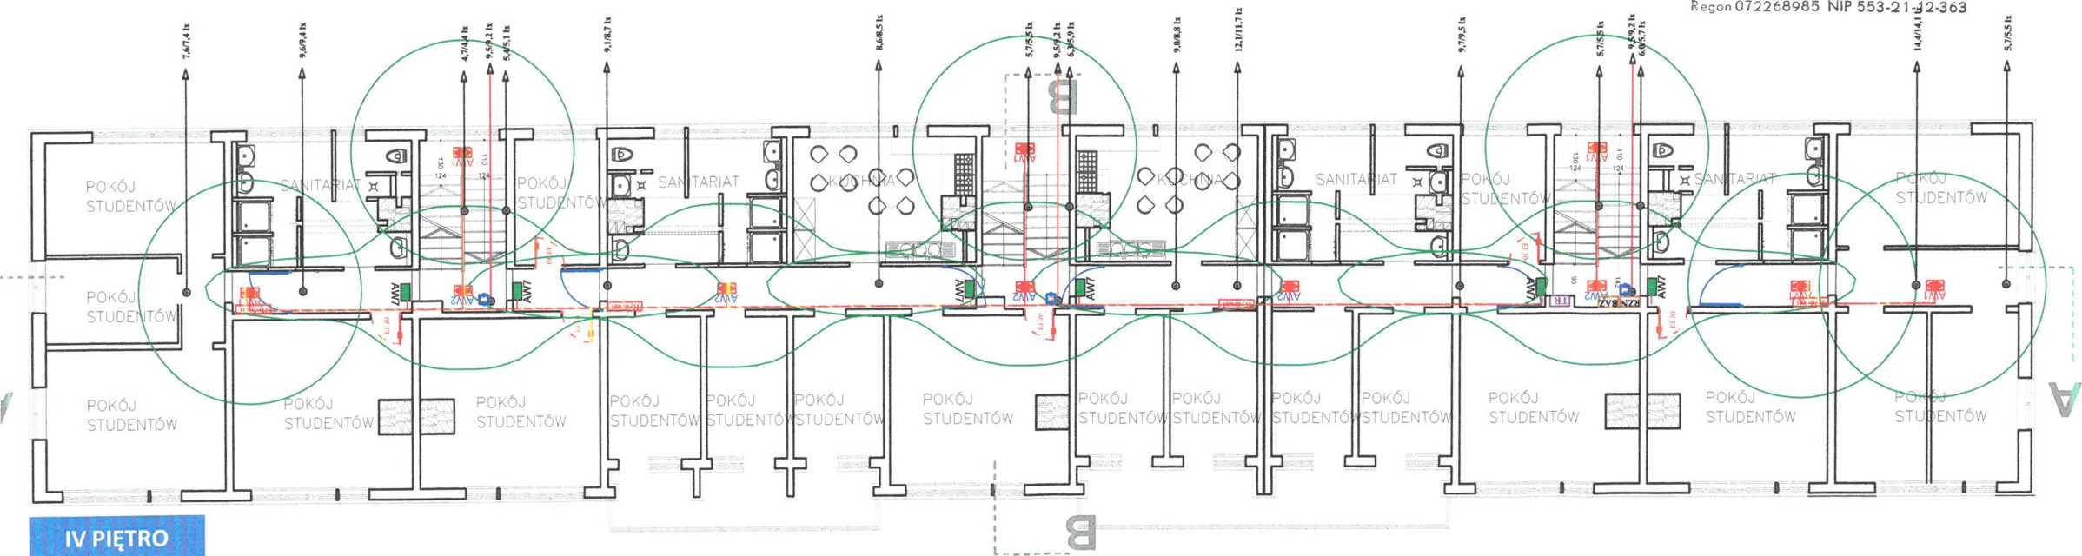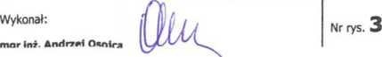

**FLOOR III**

P.U.H. „INSTAL-POŻ" s.c.

Kompleksowe zabezbieczenie p.poż.

34-300 Żywiec, ul. Ks. Pr. St. Słonki 49  
tel.|fax 033 861 11 14  
tel. 0 502 645 233, 0 502 495 665

|  |  |
| --- | --- |
| Structure name: | Investor: |
| STUDENT’S DORMITORY 2 | Akademia Techniczno-Humanistyczna |
| 43-300 Bielsko-Biała | 43-309 Bielsko-Biała |
| ul. Spółdzielców 11 | ul. Willowa 2 |
| Drawing title | Title: |
| Distribution of the emergency lighting system components. | VIEW OF FLOORS III AND IV |

KITCHEN

KITCHEN

BATH ROOM

BATH ROOM

BATH ROOM

STUDENT ROOM

STUDENT ROOM

STUDENT ROOM

STUDENT ROOM

BATH ROOM

STUDENT ROOM

STUDENT ROOM

STUDENT ROOM

STUDENT ROOM

STUDENT ROOM

STUDENT ROOM

STUDENT ROOM

STUDENT ROOM

STUDENT ROOM

STUDENT ROOM

STUDENT ROOM

STUDENT ROOM

STUDENT ROOM

STUDENT ROOM

STUDENT ROOM

STUDENT ROOM

STUDENT ROOM

BATH ROOM

STUDENT ROOM

STUDENT ROOM

BATH ROOM

BATH ROOM

BATH ROOM

KITCHEN

KITCHEN

STUDENT ROOM

STUDENT ROOM

STUDENT ROOM

STUDENT ROOM

STUDENT ROOM

STUDENT ROOM

STUDENT ROOM

STUDENT ROOM

STUDENT ROOM

STUDENT ROOM

STUDENT ROOM

STUDENT ROOM

STUDENT ROOM

STUDENT ROOM

STUDENT ROOM

FLOOR IV

KEY:

AW1 - TM Technologie - emergency lighting fitting Ontec S type M1 101 NM AT, ceiling NM (emergency operation), AT (automatic self-test), no pictogram, 7x LED - 1W, 1h, 193 lm/128 Im

AW2 - TM Technologie -emer-cy lighting fitting Ontec S type C1 102 NM AT, ceiling NM (emergency operation), AT (automatic self-test), no pictogram 1x LED - 2.5W, 1h, 204 lm/204 Im

AW3 - TM Technologie -emer-cy lighting fitting Ontec S type M2 102 NM AT, ceiling NM (emergency operation), AT (automatic self-test), no pictogram 14x LED - 2W, 1h, 235 lm/218 Im

AW4 – TM Technologie - emergency lighting fitting Ontec S type W1 302 NM COLD AT, wall NM (emergency operation), AT (automatic test)

AW5 - Hybryd - emer-cy lighting fitting ALU type LED 4 AT, ceiling dark (emergency operation), AT (automatic self-test) with Emergency exit pictogram, 4x LED - 2 W, 1 h, 193/128 Im

AW6 - Beghelli 2043 emergency lighting fitting after renovation, wall dark (emergency operation), self-test only after power cut 230V 1x 18 W G5 - 3 h

AW7 - Beghelli Formula 65 - existing direction emer-cy lighting fitting with and without pictogram after renovation, wall dark (emer-cy operation), test only after power cut 230V 1x 8 WG5- 3h

YDYp 3x 1,5 mm cable

DRAWING NO **3**

PREPARED BY

Schedule 4

DISTRIBUTION OF THE ELEMENTS  
OF THE GRAVITY SMOKE VENT SYSTEM  
IN THE STAIRCASES

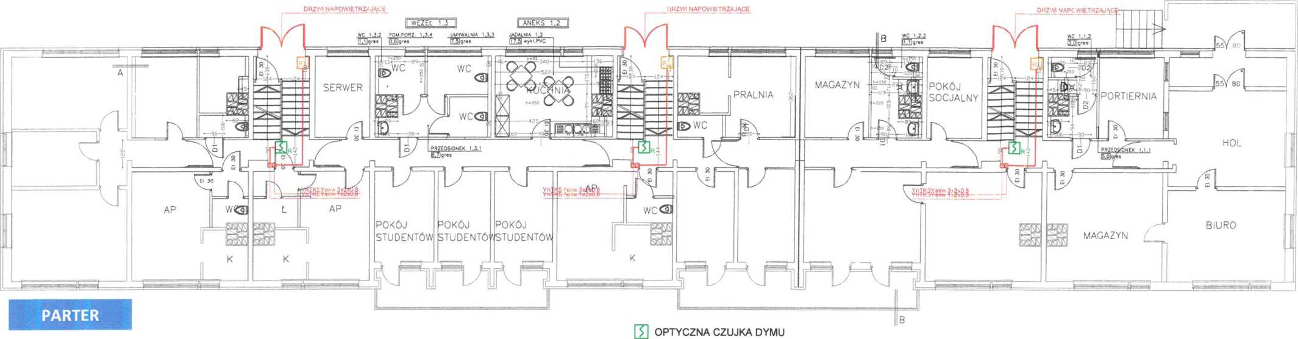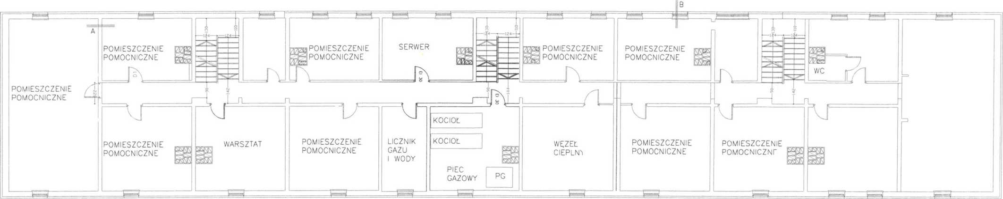

KITCHENETTE 1.2

HEATING SYS 1.3

AIR INLET DOOR

AIR INLET DOOR

AIR INLET DOOR

Kompleksowe zabezbieczenie p.poż. 34-300 Żywiec, ul. Ks. Pr. St. Słonki 49 tel./Fax 033 861 11 14

tel. 0 502 645 233, 0 502 495 665 Regon072268985 NIP 553-21 -12-363

Prepared by:

mgr inż. Andrzej Osojca

Drawing 1

DATE

JANUARY 2016

RECEPTION OFFICE

BREAK ROOM

STORE ROOM

UTILITY ROOM

SERVER

KITCHEN

HALL

STUDENT ROOM

STUDENT ROOM

STUDENT ROOM

OFFICE

STORE ROOM

GROUND FLOOR

OPTICAL SMOKE DETECTOR



SMOKE VENT BUTTON

SERVER ROOM

AUXILIARY ROOM

AUXILIARY ROOM

AUXILIARY ROOM

AUXILIARY ROOM

AUXILIARY ROOM

BOILER

DISTRICT HEATING SYSTEM

GAS&WATER METER

PG - GAS FURNACE

BOILER

WORKSHOP

AUXILIARY ROOM

AUXILIARY ROOM

AUXILIARY ROOM

AUXILIARY ROOM

**BASEMENT**

|  |  |
| --- | --- |
| Structure name:  STUDENT’S DORMITORY 2, 43-300 Bielsko-Biała ul. Spółdzielców 11 | Investor:  Akademia Techniczno-Humanistyczna 43-309 Bielsko-Biała ul. Willowa 2 |
| Drawing title  Distribution of the elements of the gravity smoke vent system in the staircases | Title:  VIEW OF BASEMENT AND GROUND FLOOR |

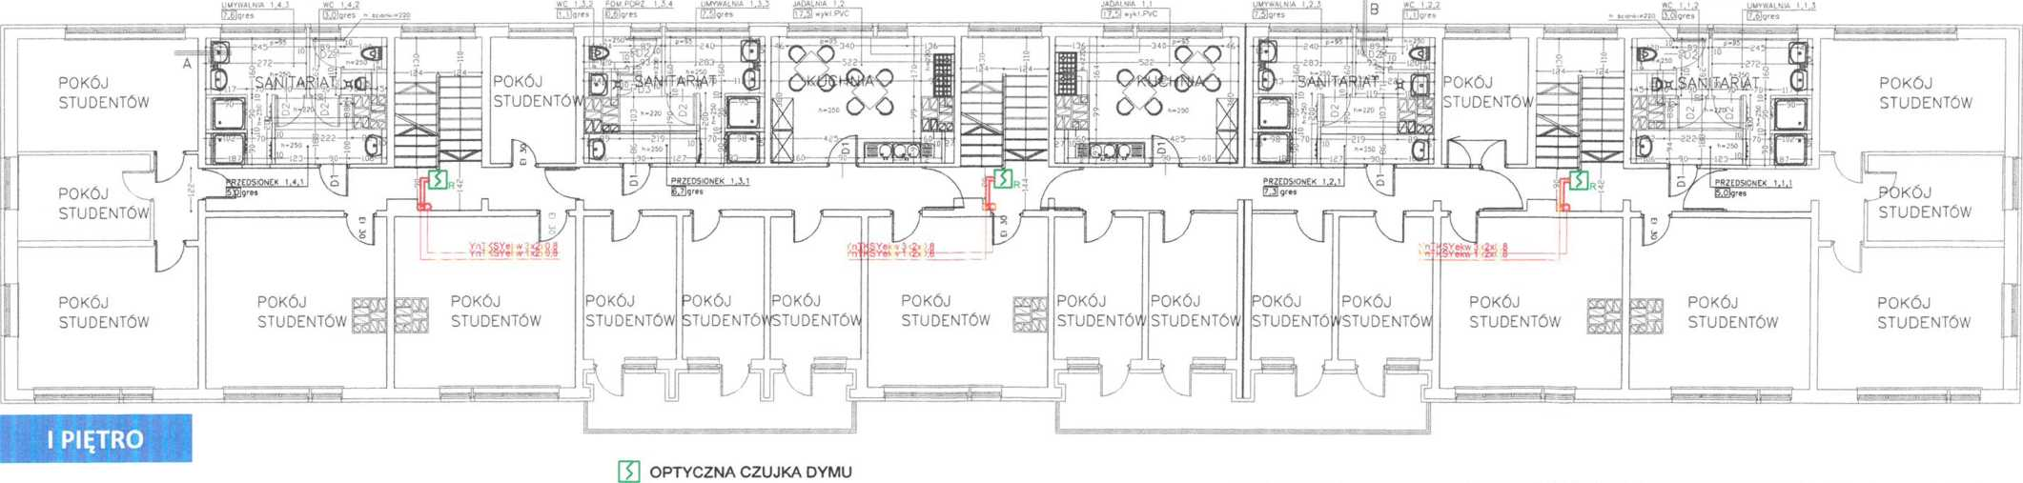

KITCHENETTE 2.1

KITCHENETTE 2.2

DISTR HEATING SYS 2.1

DISTR HEATING SYS 2.2

DISTR HEATING SYS 2.3

DISTR HEATING SYS 2.4

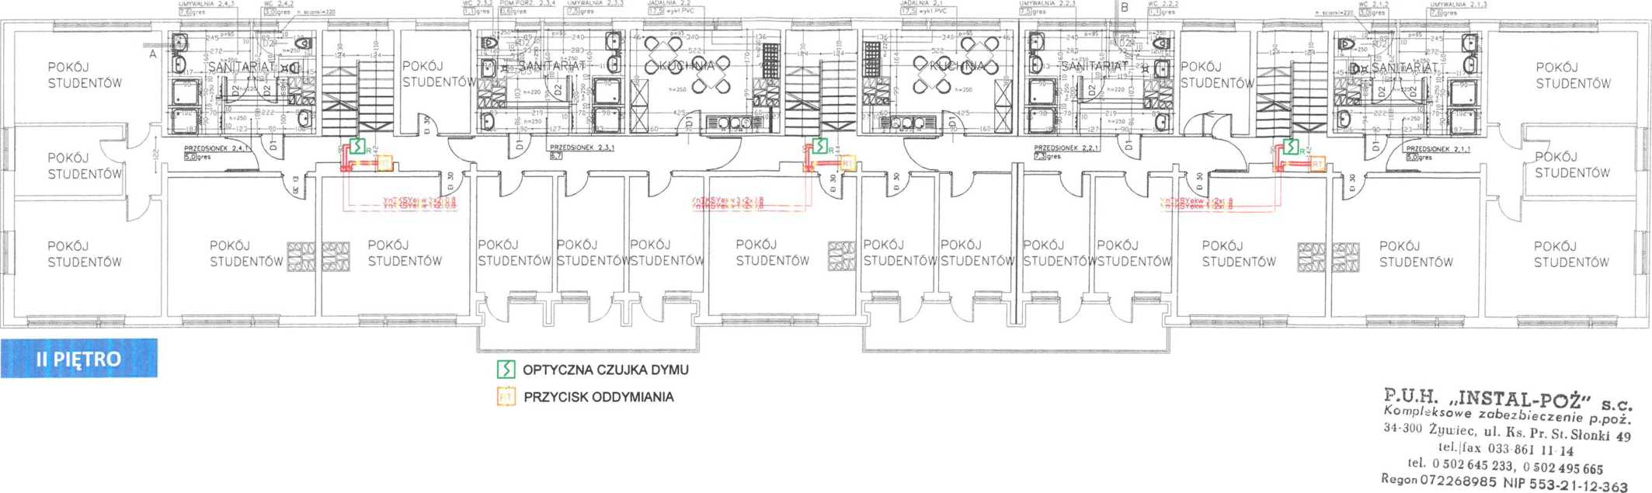

KITCHENETTE 1.1

DISTRICT HEATING SYSTEM 1.4

DISTRICT HEATING SYSTEM 1.3

DISTRICT HEATING SYSTEM 1.2

DISTRICT HEATING SYSTEM 1.1

KITCHEN

KITCHEN

BATH ROOM

BATH ROOM

BATH ROOM

BATH ROOM

STUDENT ROOM

STUDENT ROOM

STUDENT ROOM

STUDENT ROOM

STUDENT ROOM

STUDENT ROOM

STUDENT ROOM

STUDENT ROOM

STUDENT ROOM

STUDENT ROOM

STUDENT ROOM

STUDENT ROOM

STUDENT ROOM

STUDENT ROOM

STUDENT ROOM

STUDENT ROOM

STUDENT ROOM

STUDENT ROOM

STUDENT ROOM

STUDENT ROOM

FLOOR II

OPTICAL SMOKE DETECTOR

SMOKE VENT BUTTON

DISTR HEATING SYS 1.2

KITCHENETTE 1.2

KITCHENETTE 1.1

DISTR HEATING SYS 1.1

DISTR HEATING SYS 1.3

DISTR HEATING SYS 1.4

KITCHEN

KITCHEN

BATH ROOM

BATH ROOM

BATH ROOM

BATH ROOM

STUDENT ROOM

STUDENT ROOM

STUDENT ROOM

STUDENT ROOM

STUDENT ROOM

STUDENT ROOM

|  |  |  |
| --- | --- | --- |
| Structure name:  STUDENT’S DORMITORY 2, 43-300 Bielsko-Biała ul. Spółdzielców 11 | Investor:  Akademia Techniczno-Humanistyczna 43-309 Bielsko-Biała ul. Willowa 2 | |
| Drawing title | Title: |  |
| Distribution of the elements of the gravity smoke vent system in the staircases | VIEW OF FLOORS I AND Ii | |
| Prepared  mgr inż. Andrzej Osojca | Drawing 2 | DATE  JANUARY 2016 |

FLOOR I

STUDENT ROOM

STUDENT ROOM

STUDENT ROOM

STUDENT ROOM

STUDENT ROOM

STUDENT ROOM

STUDENT ROOM

STUDENT ROOM

STUDENT ROOM

STUDENT ROOM

STUDENT ROOM

STUDENT ROOM

STUDENT ROOM

STUDENT ROOM

OPTICAL SMOKE DETECTOR



SMOKE VENT BUTTON

KITCHENETTE 4.1

KITCHENETTE 4.2

SMOKE VENT

SMOKE VENT

SMOKE VENT

DISTRICT HEATING SS 4.1

DISTRICT HEATING SS 4.2

DISTRICT HEATING SS 4.3

DISTRICT HEATING SS 4.4

KITCHEN

KITCHEN

BATH ROOM

BATH ROOM

BATH ROOM

BATH ROOM

STUDENT ROOM

STUDENT ROOM

STUDENT ROOM

STUDENT ROOM

STUDENT ROOM

STUDENT ROOM



DATE

**JANUARY 2016**

DRAWING NO **3**

TITLE

**VIEW OF FLOORS III AND IV**

PREPARED:

DRAWING TITLE

**DISTRIBUTION OF THE ELEMENTS OF THE GRAVITY SMOKE SYSTEM IN THE STAIRCASES**

BUILDING

**STUDENTS’ DORMITOROY 2**

43-300 BIELSKO-BIAŁA, UL. SPÓŁDZIELCÓW 11

OPTICAL SMOKE DETECTOR

SMOKE VENT BUTTON

OPTICAL SMOKE DETECTOR

SMOKE VENT BUTTON

FLOOR III

DISTRICT HEATING SYS 3.1

DISTRICT HEATING SYS 3.2.

DISTRICT HEATING SYS 3.3.

DISTRICT HEATING SYS 3.4.

KITCHENETTE 3.2

KITCHENETTE 3.1

KITCHEN

KITCHEN

BATH ROOM

BATH ROOM

BATH ROOM

BATH ROOM

STUDENT ROOM

STUDENT ROOM

STUDENT ROOM

STUDENT ROOM

STUDENT ROOM

STUDENT ROOM

STUDENT ROOM

STUDENT RM

STUDENT RM

STUDENT ROOM

STUDENT ROOM

STUDENT ROOM

STUDENT ROOM

STUDENT ROOM

STUDENT ROOM

STUDENT ROOM

STUDENT ROOM

STUDENT ROOM

STUDENT ROOM

STUDENT ROOM

STUDENT ROOM

STUDENT ROOM

STUDENT ROOM

STUDENT ROOM

STUDENT ROOM

STUDENT ROOM

STUDENT ROOM

STUDENT ROOM

STUDENT ROOM

STUDENT ROOM

STUDENT ROOM

STUDENT ROOM

STUDENT ROOM

STUDENT ROOM

FLOOR IV

Schedule 5

**DISTRIBUTION OF THE OUTDOOR HYDRANTS**



**SCHEDULE 5**

**DISTRIBUTION OF OUTDOOR HYDRANTS**

OUTDOOR HYDRANT DN80

STUDENT’S DORMITORY

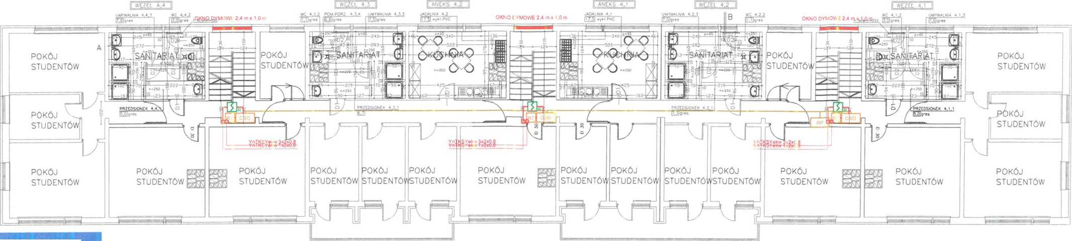P.U.H. „INSTAL-POŻ" s.c.

**FLOOR IV**

OPTICAL SMOKE DETECTOR SMOKE VENT BUTTON

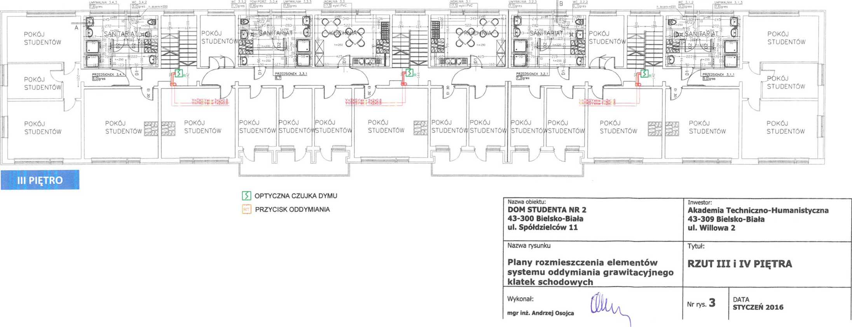Kompleksowe zabezbieczenie p.poż.  
34-300 Żywiec, ul. Ks. Pr. St. Słonki 49  
tel.|fax 033 861 11 14  
tel. 0 502 645 233, 0 502 495 665  
Regon 072268985 NIP 553-21-12-363

DISTRICT HEATING SYSTEM 3.4

DISTRICT HEATING SYSTEM 3.3

DISTRICT HEATING SYSTEM 3.2

DISTRICT HEATING SYSTEM 3.1

Schedule 5

DISTRIBUTION OF OUTDOOR HYDRANTS

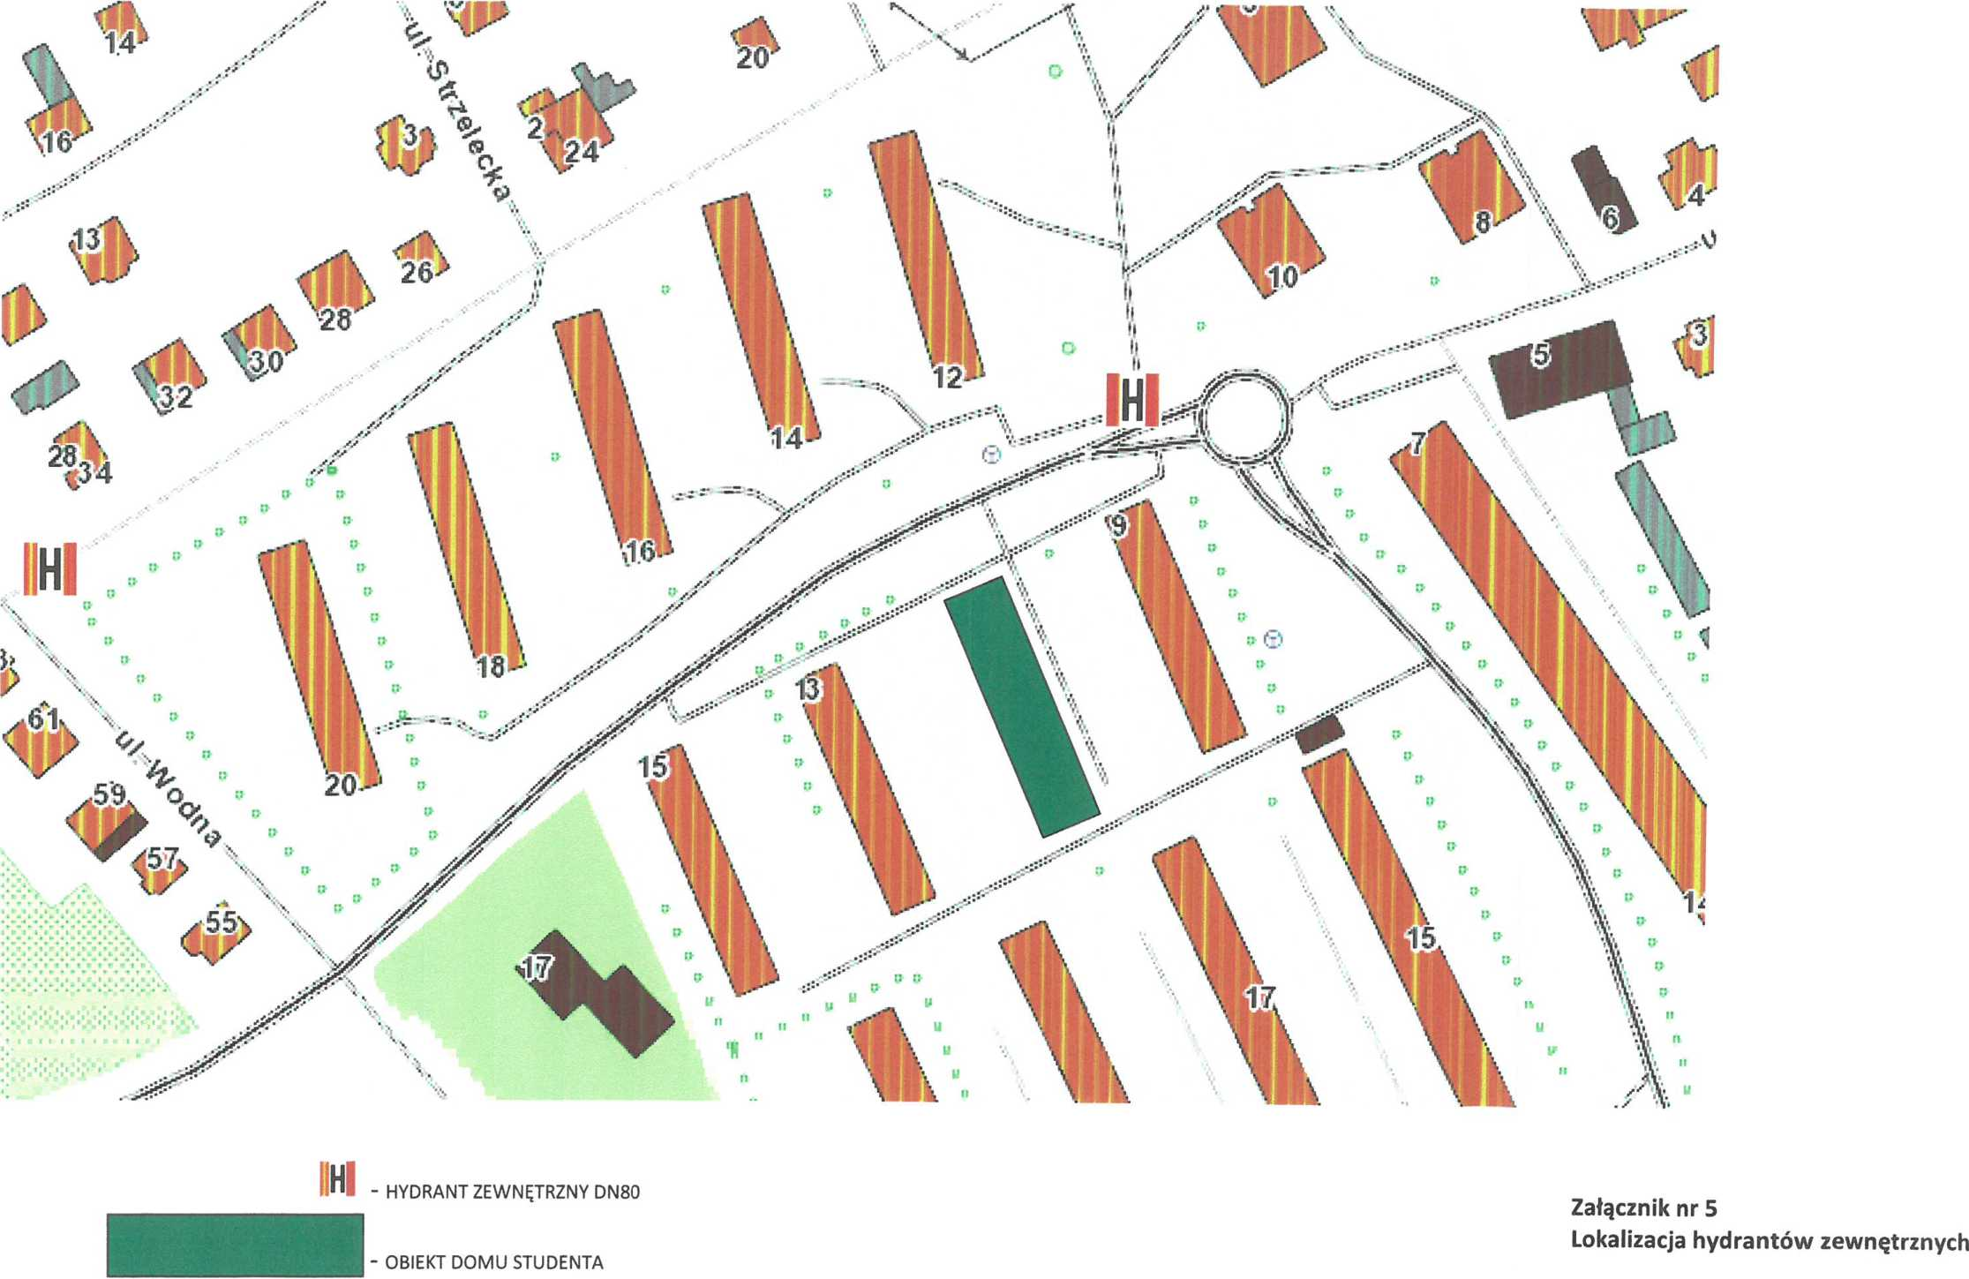

tel. 0 502 645 233, 0 502 495 665  
Regon 072268985 NIP 553-22-363 XXXX

1. The Fire Safety Instruction shall be revised periodically, at least once in two years, and each time after any changes in the use of the building or in the technological process that affect the fire protection conditions.
2. As specified in the smoke exhaust control unit’s O&M